Supplementary Tables and Figures
Table S1. Taxa categorized by results of single classification G-tests and replicated tests for goodness of fit after p-value correction. Decreaser taxa significantly decreased in frequency of occurrence from 1982 to 2010/2011, increaser taxa significantly increased, and no-change taxa were not significant. The number of ponds (of 22) a taxa was significantly increasing or decreasing in before (outside of parentheses) and after (inside parentheses) p-value correction. Asterisks indicate exotic or hybrid taxa. Species were classified as emergent (E) or submersed/floating (S/F) based on where the majority of the foliage is typically found. Calculated pooled G scores (Gpool) and total G scores (G tot) are presented; df for Gpool was always 1.
Decreaser taxa | Habit | Ponds 1982 | Ponds 2010 | # Ponds Increasing | # Ponds Decreasing | %Frequency Change | Gpool | Gtot | df het
Ranunculus flabellaris | S/F | 7 | 1 | 0 | 5 (3) | -99 | 65.17 | 68.94 | 7
Eleocharis sp. | E | 14 | 5 | 1 (0) | 8 (7) | -91 | 92.87 | 153.14 | 17
Iris virginica | E | 4 | 3 | 0 | 2 (0) | -83 | 9.99 | 20.63 | 6
Juncus sp. | E | 7 | 8 | 0 | 3 (3) | -82 | 31.47 | 64.45 | 11
Calamagrostis canadensis | E | 8 | 11 | 1 (0) | 6 (4) | -79 | 30.87 | 93.21 | 17
Stuckenia pectinata | S/F | 5 | 3 | 0 | 3 (3) | -74 | 18.52 | 34.42 | 6
Dulichium arundinaceum | E | 5 | 5 | 0 | 3 (1) | -72 | 9.49 | 42.09 | 10
Proserpinaca palustris | S/F | 11 | 8 | 0 | 8 (5) | -68 | 30.04 | 94.66 | 15
Persicaria amphibium | E | 15 | 16 | 0 | 6 (3) | -64 | 40.62 | 82.77 | 18
Sagittaria latifolia | E | 8 | 10 | 2 (0) | 2 (2) | -64 | 18.27 | 64.91 | 11
Nuphar sp. | S/F | 13 | 13 | 1 (0) | 3 (0) | -61 | 23.21 | 57.29 | 14
Schoenoplectus acutus | E | 14 | 18 | 1 (0) | 6 (3) | -60 | 22.92 | 97.44 | 20
Chara sp. | S/F | 13 | 9 | 0 | 6 (4) | -59 | 55.97 | 122.40 | 14
Najas flexilis | S/F | 11 | 11 | 1 (0) | 3 (1) | -41 | 10.85 | 76.80 | 14
Myriophyllum verticillatum | S/F | 13 | 14 | 2 (1) | 4 (2) | -30 | 10.68 | 119.08 | 15
Increaser taxa
Utricularia macrorhiza | S/F | 18 | 18 | 6 (5) | 4 (3) | 52 | 22.36 | 228.96 | 20
Typha x glauca* | E | 13 | 15 | 4 (1) | 1 (1) | 65 | 39.04 | 208.28 | 22
Nymphaea odorata | S/F | 7 | 13 | 4 (2) | 1 (0) | 66 | 9.98 | 66.55 | 13
Potamogeton narrow-leafed | S/F | 9 | 16 | 6 (4) | 2 (2) | 106 | 15.05 | 94.73 | 18
Persicaria hydropiperoides | E | 4 | 10 | 3 (2) | 1 (1) | 131 | 9.05 | 60.36 | 11
Zizania palustris | E | 4 | 12 | 4 (1) | 0 | 151 | 11.28 | 32.97 | 12
Carex sp. | E | 3 | 15 | 0 | 0 | 199 | 9.47 | 39.62 | 16
Cephalanthus occidentalis | E | 4 | 7 | 2 (0) | 0 | 258 | 18.50 | 20.05 | 7
Phragmites australis* | E | 2 | 16 | 8 (7) | 0 | 2081 | 81.46 | 109.36 | 18
Lythrum salicaria* | E | 0 | 19 | 9 (4) | N/A | Colonization | 87.58 | 87.58 | 19
No change taxa
Nitella sp. | S/F | 7 | 4 | 1 (0) | 0 | -59 | 4.12 | 23.24 | 10
Alisma subcordatum | E | 2 | 6 | 0 | 0 | -57 | 2.15 | 11.27 | 6
Scirpus sp. | E | 8 | 3 | 1 (0) | 3 (0) | -53 | 4.57 | 23.17 | 8
Poaceae sp. | E | 3 | 10 | 0 | 1 (0) | -40 | 2.06 | 29.30 | 11
Pontederia cordata | E | 3 | 5 | 1 (0) | 1 (0) | -10 | 0.03 | 17.14 | 7
Sparganium emersum | E | 14 | 16 | 2 (1) | 2 (1) | -8 | 0.23 | 56.91 | 18
Utricularia gibba | S/F | 6 | 6 | 2 (1) | 1 (1) | -6 | 0.09 | 53.30 | 8
Potamogeton wide-leafed | S/F | 16 | 17 | 5 (1) | 2 (1) | 0 | 0.00 | 72.99 | 20
Thelypteris palustris | E | 5 | 9 | 1 (0) | 1 (0) | 20 | 0.16 | 17.68 | 12
Lycopus sp. | E | 1 | 7 | 0 | 0 | 65 | 0.67 | 16.11 | 8
Lemna minor | S/F | 1 | 10 | 1 (0) | 1 (0) | 124 | 2.54 | 16.15 | 10
Potamogeton robbinsii | S/F | 1 | 1 | 0 | 0 | 200 | 2.64 | 2.64 | 1
Scutellaria sp. | E | 1 | 4 | 0 | 0 | 380 | 3.53 | 4.08 | 4

Table S2. Mean (standard error) percent area covered across ponds of each of the five invader species in the 2010/2011 sampling period. Asterisks indicate significant differences between young and old ponds as evaluted by Wilcoxon tests.
 | All ponds  (N=22) | Young ponds only  (N=10) | Old ponds  (N=12)
Persicaria hydropiperoides | 0.48 (0.45) | 0.03 (0.02) | 0.86 (0.82)
Cephalanthus occidentalus | 2.54 (1.34) | 0.02 (0.006) | 4.64 (2.32)*
Typha x glauca | 7.91 (2.23) | 1.45 (0.99) | 13.30 (3.3)*
Phragmites australis | 11.48 (4.53) | 18.48 (8.72) | 5.65 (3.64)*
Lythrum salicaria | 0.70 (0.26) | 0.67 (0.49) | 0.72 (0.25)

Table S3. Results of ANOVAs predicting proportional change in pond-scale richness or Pileou’s evenness from 1982 to 2010/2011 from pond age group and invader coverage in the resample period. Pond was included as a random effect. Invader variables are arcsin(sqrt)-transformed pond-level proportion cover values from the modern (2010/2011) time period. Each model included one target invader, with the other four invaders included as a second predictive variable (“Others”). Interactions factors were included in the original model, and removed if they were not significant (p>0.05).

Richness change |  |  |  | Evenness change
Adj R² | Source | F Ratio | P | Adj R² | Source | F Ratio | P
0.653 | Age | 14.47 | 0.0014* | 0.085 | Age | 2.26 | 0.015*
 | Phragmites | 6.62 | 0.0197* |  | Phragmites | 2.07 | 0.168
 | Others | 0.04 | 0.849 |  | Others | 0.06 | 0.899
 | Age*Phragmites | 4.52 | 0.0485*
0.609 | Age | 10.69 | 0.0043* | 0.277 | Age | 5.40 | 0.034*
 | Typha | 0.38 | 0.541 |  | Typha | 1.52 | 0.236
 | Others | 17.44 | 0.0006* |  | Others | 0.47 | 0.500
 |  |  |  |  | Age*Typha | 4.87 | 0.042*
0.663 | Age | 11.36 | 0.0034* | 0.238 | Age | 2.23 | 0.153
 | Lythrum | 0.587 | 0.453 |  | Lythrum | 2.71 | 0.117
 | Others | 22.81 | 0.0002* |  | Others | 5.12 | 0.036*
0.659 | Age | 15.91 | 0.0009* | 0.192 | Age | 3.46 | 0.079
 | Persicaria | 0.80 | 0.382 |  | Persicaria | 1.15 | 0.297
 | Others | 22.36 | 0.0002* |  | Others | 2.21 | 0.154
0.648 | Age | 11.09 | 0.0037* | 0.145 | Age | 2.45 | 0.135
 | Cephalanthus | 0.00 | 0.971 |  | Cephalanthus | 0.36 | 0.554
 | Others | 21.37 | 0.0002* |  | Others | 3.23 | 0.089

Table S4. Characteristics of 0.5 m² quadrats placed in patches of species or nearby reference areas.
Patch Type | Light availability | Water Depth (cm) | Percent Cover of Patch Species | Max height of Patch species (cm)
Reference | 89.1 (2.77) ª | 50.0 (1.76) ª | N/A | N/A
Cephalanthus occidentalis | 11.2 (1.23) ^{c} | 45.0 (1.18) ª | 77.6 (2.50) | 152 (6.34) ª
Schoenoplectus acutus | 27.7 (2.20) ^{b} | 26.7 (1.35) ^{c} | 69.2 (3.73) | 160 (2.91) ª
Phragmites australis | 12.8 (2.25) ^{c} | 24.2 (1.83) ^{c} | 72.5 (4.25) | 251 (6.73) ^{c}
Typha x glauca | 17.7 (1.96) ^{c} | 36.0 (1.87) ^{b} | 71.4 (3.30) | 220 (5.03) ^{b}

Figure S1.Aerial view of the Miller Woods study area, based on HI-Res 2008 Orthophotos. White ponds are those sampled via transects in 1982 and 2010/2011. Black ponds with white outlines are those sampled via quadrats in different patch types. Lined ponds are those sampled for the transect-level resurvey and the quadrat-level patch analysis. Pond age increases from NNE to SSW.
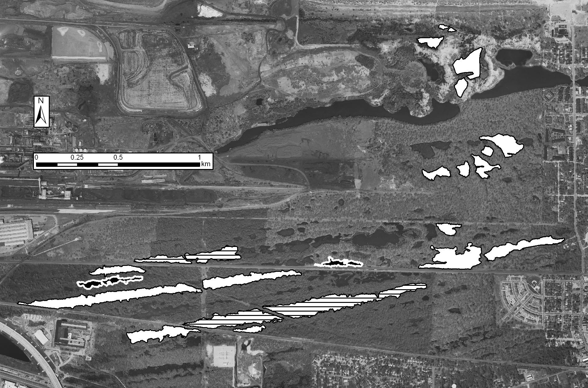

Figure S2. Relationship between the 2010/2011 combined cover of all invaders (Cephalanthus occidentalis, Typha x glauca, Lythrum salicara, Persicaria hydropiperoides, and Phragmites australis) and the amount of pond shoreline altered by roads or railroads. Both variables are arcsin(sqrt)-transformed. Black circles are young ponds, gray squares are old ponds. Young pond and all pond regressions are significant (p < 0.05); the relationship in just old ponds is significant at p<0.10 level.
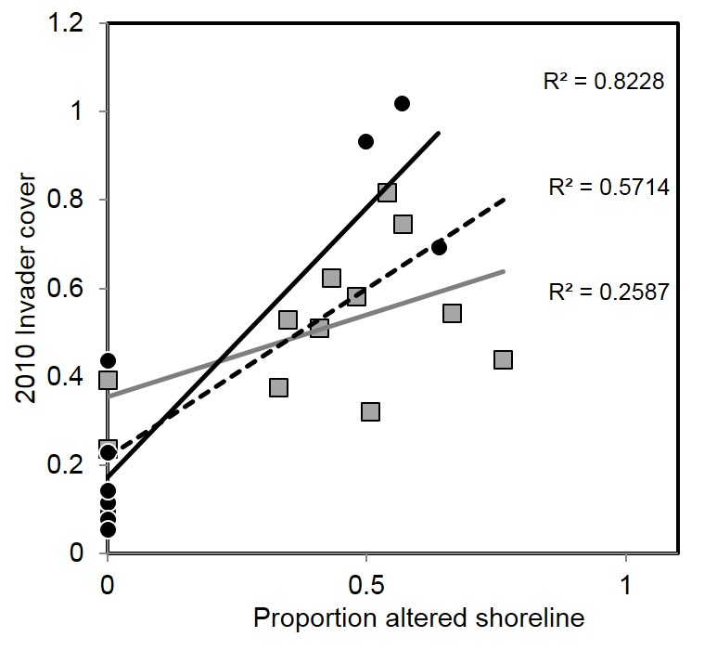

Figure S3. 0.5 m² quadrat-level evenness of taxa in areas dominated by Cephalanthus occidentalis (native), Schoenoplectus acutus (native), Phragmites australis (exotic), Typha x glauca (native-exotic hybrid) or reference areas. Mixed-model ANOVA is significant at p< 0.05.
