Supplementary materials for:

Consistency of impact assessment protocols for non-native species

Pablo González-Moreno^{1*}, Lorenzo Lazzaro², Montserrat Vilà³, Cristina Preda^{4,5}, Tim Adriaens⁶, Sven Bacher⁴, Giuseppe Brundu⁷, Gordon H Copp^{8, 9}, Franz Essl¹⁰, Emili García-Berthou¹¹, Stelios Katsanevakis¹², Toril Loennechen Moen¹³, Frances E Lucy¹⁴, Wolfgang Nentwig¹⁵, Helen E Roy¹⁶, Greta Srėbalienė¹⁷, Venche Talgø¹⁸, Sonia Vanderhoeven¹⁹, Ana Andjelković^{20,21}, Kęstutis Arbačiauskas²², Marie-Anne Auger-Rozenberg²³, Mi-Jung Bae^{11,24}, Michel Bariche²⁵, Pieter Boets²⁶, Mário Boieiro²⁷, Paulo Alexandre Borges²⁷, João Canning-Clode^{28,29,30}, Frederico Cardigos³¹, Niki Chartosia³², Elizabeth Joanne Cottier-Cook³³, Fabio Crocetta³⁴, Bram D'hondt³⁵, Bruno Foggi², Swen Follak³⁶, Belinda Gallardo³⁷, Øivind Gammelmo³⁸, Sylvaine Giakoumi³⁹, Claudia Giuliani⁴⁰, Fried Guillaume⁴¹, Lucija Šerić Jelaska⁴², Jonathan M Jeschke^{43,44,45}, Miquel Jover⁴⁶, Alejandro Juárez-Escario^{47, 48}, Stefanos Kalogirou⁴⁹, Aleksandra Kočić⁵⁰, Eleni Kytinou⁵¹, Ciaran Laverty⁵², Vanessa Lozano⁷, Alberto Maceda-Veiga³, Elizabete Marchante⁵³, Hélia Marchante^{53,54}, Angeliki F Martinou⁵⁵, Sandro Meyer⁵⁶, Dan Michin^{57,58}, Ana Montero-Castaño³, Maria Cristina Morais^{53,59}, Carmen Morales-Rodriguez⁶⁰, Nadia Muhthassim¹⁵, Zoltán Á Nagy⁶¹, Nikica Ogris⁶², Huseyin Onen⁶³, Jan Pergl⁶⁴, Riikka Puntila⁶⁵, Wolfgang Rabitsch⁶⁶, Triya Tessa Ramburn⁶⁷, Carla Rego²⁷, Fabian Reichenbach¹⁵, Carmen Romeralo^{68,69}, Wolf-Christian Saul^{43,44,45}, Gritta Schrader⁷⁰, Rory Sheehan¹⁴, Predrag Simonović⁷¹, Marius Skolka⁵, António Onofre Soares⁷², Leif Sundheim¹⁸, Ali Serhan Tarkan⁷³, Rumen Tomov⁷⁴, Elena Tricarico², Konstantinos Tsiamis⁷⁵, Ahmet Uludağ⁷⁶, Johan van Valkenburg⁷⁷, Hugo Verreycken⁷⁸, Anna Maria Vettraino⁷⁹, Lluís Vilar⁴⁶, Øystein Wiig⁸⁰, Johanna Witzell⁶⁹, Andrea Zanetta^{4,81}, Marc Kenis⁸²

*Corresponding author
- CABI, Egham, UK
- Department of Biology, University of Florence, Florence, Italy
- Estación Biológica de Doñana (EBD-CSIC), Sevilla, Spain
- University of Fribourg, Department of Biology, Fribourg, Switzerland
- Ovidius University of Constanta, Department of Natural Sciences, Constanta, Romania
- Research Institute for Nature and Forest (INBO), Brussels, Belgium
- Department of Agriculture, University of Sassari, Sassari, Italy
- Salmon & Freshwater Team, Cefas, Lowestoft, U.K.
- Centre for Conservation Ecology and Environmental Science, Bournemouth University, Poole, U.K.
- Division of Conservation, Vegetation and Landscape Ecology, University Vienna, Vienna, Austria
- GRECO, Institute of Aquatic Ecology, University of Girona, Girona, Spain
- University of the Aegean, Department of Marine Sciences, Mytilene, Greece
- Norwegian Biodiversity Information Centre. Trondheim. Norway
- CERIS, Institute of Technology, Sligo, Ireland
- Institute of Ecology and Evolution, University of Bern, Bern, Switzerland
- Centre for Ecology & Hydrology, Crowmarsh Gifford, UK
- Marine Science and Technology Centre, Klaipėda University, Klaipėda, Lithuania
- Norwegian Institute of Bioeconomy Research (NIBIO), Ås, Norway
- Belgian Biodiversity Platform, Walloon Research Department for Nature and Agricultural Areas (DEMNA), Service Public de Wallonie, Gembloux, Belgium.
- Institute for Plant Protection and Environment, Belgrade, Serbia
- Department of Biology and Ecology, Faculty of Sciences, University of Novi Sad, Novi Sad, Serbia
- Nature Research Centre, Akademijos Street 2, LT-08412 Vilnius, Lithuania
- INRA, UR633, Zoologie Forestière (URZF), Orléans, France
- Freshwater Biodiversity Research Division, Nakdonggang National Institute of Biological Resources, Gyeongsangbuk-do 37242, Republic of Korea.
- Department of Biology, American University of Beirut, Beirut, Lebanon
- Provincial Centre of Environmental Research (PCM), Ghent, Belgium
- cE3c – Centre for Ecology, Evolution and Environmental Changes/Azorean Biodiversity Group and Universidade. dos Açores – Depto de Ciências e Engenharia do Ambiente, Azores, Portugal
- MARE – Marine and Environmental Sciences Centre, Madeira Island, Portugal
- Centre of IMAR of the University of the Azores, Department of Oceanography and Fisheries. Horta, Azores, Portugal
- Smithsonian Environmental Research Center, Edgewater, MD 21037, USA.
- OKEANOS - Research Center – Universidade dos Açores, Azores, Portugal
- Department of Biological Sciences, University of Cyprus, Nicosia, Cyprus
- Scottish Association for Marine Science, Scottish Marine Institute, Oban, U.K.
- Department of Integrative Marine Ecology, Stazione Zoologica Anton. Dohrn, Villa Comunale, I-80121 Napoli, Italy
- Biology Department, Ghent University, Ghent, Belgium
- Austrian Agency for Health and Food Safety, Institute for Sustainable Plant Production, Vienna, Austria
- Applied and Restoration Ecology Group (IPE-CSIC), Zaragoza (Spain)
- BioFokus, Oslo, Norway
- Université Côte d'Azur, CNRS, UMR 7035 ECOSEAS, Nice, France
- Department of Pharmaceutical Sciences (DISFARM), University of Milan, Milane, Italy
- Plant Health Laboratory, Anses, Montferrier-sur-Lez, France
- Department of Biology, Faculty of Science, University of Zagreb, Zagreb, Croatia
- Leibniz-Institute of Freshwater Ecology and Inland Fisheries (IGB), Berlin, Germany
- Freie Universität Berlin, Department of Biology, Chemistry, Pharmacy, Institute of Biology, Berlin, Germany
- Berlin-Brandenburg Institute of Advanced Biodiversity Research (BBIB), Berlin, Germany
- Unitat de Botànica, Facultat de Ciències, Campus de Montilivi, University of Girona, Girona, Spain
- Department of Horticulture, Fruit Growing, Botany and Gardening, Agrotecnio, ETSEA, University of Lleida, Spain
- Department of Forest and Crop Science, Agrotecnio, ETSEA, University of Lleida, Spain
- Hellenic Centre for Marine Research, Hydrobiological, Rhodes, Greece
- Department of Biology, Josip Juraj Strossmayer University of Osijek, Osijek, Croatia
- Department of Marine Sciences, University of the Aegean, Lesvos Island, Greece
- School of Biological Sciences, Medical and Biological Centre, Queen's University Belfast, UK
- Centre for Functional Ecology, Department of Life Sciences, University of Coimbra, Coimbra, Portugal
- Instituto Politécnico de Coimbra, Escola Superior Agrária de Coimbra, Coimbra, Portugal
- Joint Services Health Unit, RAF Akrotiri, British Forces Cyprus, Cyprus
- Department of Environmental Sciences, University of Basel, Basel, Switzerland
- Marine Science and Technology Centre, Klaipeda University, Klaipeda, Lithuania
- Marine Organism Investigations, Ballina, Killaloe, Ireland
- Centre for the Research and Technology of Agro-Environmental and Biological Sciences, Department of Biology and Environment, University of Tras-os-Montes and Alto Douro, Vila Real, Portugal
- Pathology of Woody Plants. Technische Universität München, TUM, Freising, Germany
- Phytophthora Research Centre, Department of Forest Protection and Wildlife Management, Faculty of Forestry and Wood Technology, Mendel University in Brno; Brno, Czech Republic
- Slovenian Forestry Institute, Ljubljana, Slovenia
- Department of Plant Protection, Faculty of Agriculture, Gaziosmanpasa University, Tokat, Turkey
- Department of Invasion Ecology, Institute of Botany, The Czech Academy of Sciences, Průhonice, Czech Republic
- Marine Research Centre, Finnish Environment Institute, Helsinki, Finland
- Environment Agency Austria, Vienna, Austria
- Simon Fraser University, Burnaby, Canada
- Sustainable Forest Management Research Institute, University of Valladolid-INIA, Palencia, Spain
- Swedish University of Agricultural Sciences, Faculty of Forest Sciences, Southern Swedish Forest Research Centre, Alnarp, Sweden
- Julius Kuehn Institute (JKI), Braunschweig, Germany
- Faculty of Biology & Institute for Biological Research "Siniša Stanković", University of Belgrade, Belgrade, Serbia
- cE3c – Centre for Ecology, Evolution and Environmental Changes/Azorean Biodiversity Group and University of the Azores – Faculty of Sciences and Technology, Açores, Portugal
- Faculty of Fisheries, Muğla Sıtkı Koçman University, Muğla, Turkey
- University of Forestry, Department of Plant Protection, Sofia, Bulgaria
- European Commission, Joint Research Centre (JRC), Ispra, Italy
- Faculty of Agriculture, Çanakkale Onsekiz Mart University, Çanakkale, Turkey
- National Plant Protection Organization (NPPO), Wageningen,The Netherlands
- Research Institute For Nature and Forest (INBO), Linkebeek, Belgium
- Department for Innovation in Biological, Agro-food and Forest systems, University of Tuscia, Viterbo, Italy
- Natural History Museum, University of Oslo, Oslo, Norway
- Swiss Federal Research Institute WSL, Biodiversity and Conservation Biology, Birmensdorf, Switzerland
- CABI, Delémont, Switzerland

Fig S1. Spearman correlation matrix and hierarchical cluster of the species rankings for the six protocols common to all taxonomic groups (GISS,GB-NNRA, Harmonia+, EICAT, GABLIS, NGEIAAS) separately calculated for the following species groups: all species, plants, terrestrial invertebrates and aquatic animals (see Table S1 for species in each group). The colour scale indicates the degree of pair-wise correlation between the species rankings obtained for each protocol. In brackets, the mean of all pair-wise Spearman correlations between protocols for each group. See main text for abbreviations.

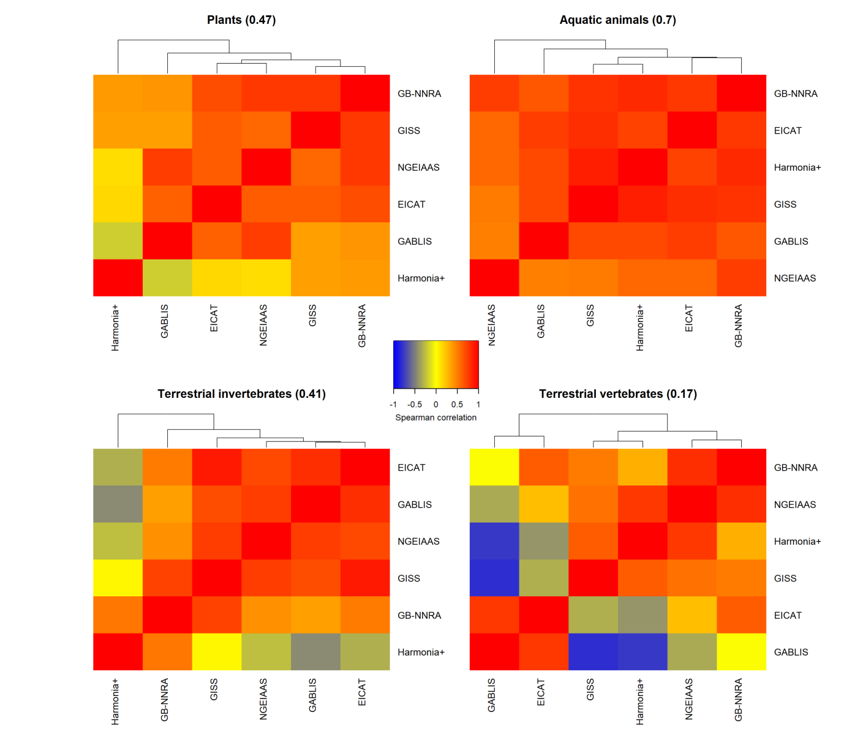
Figure S2. Spearman correlation matrix and hierarchical cluster of the species scorings for plants and aquatic animals without correcting for sample size bias. The color scale indicates the correlation between the species scorings obtained for each protocol pair. In brackets, the mean of all pairwise correlations per group.

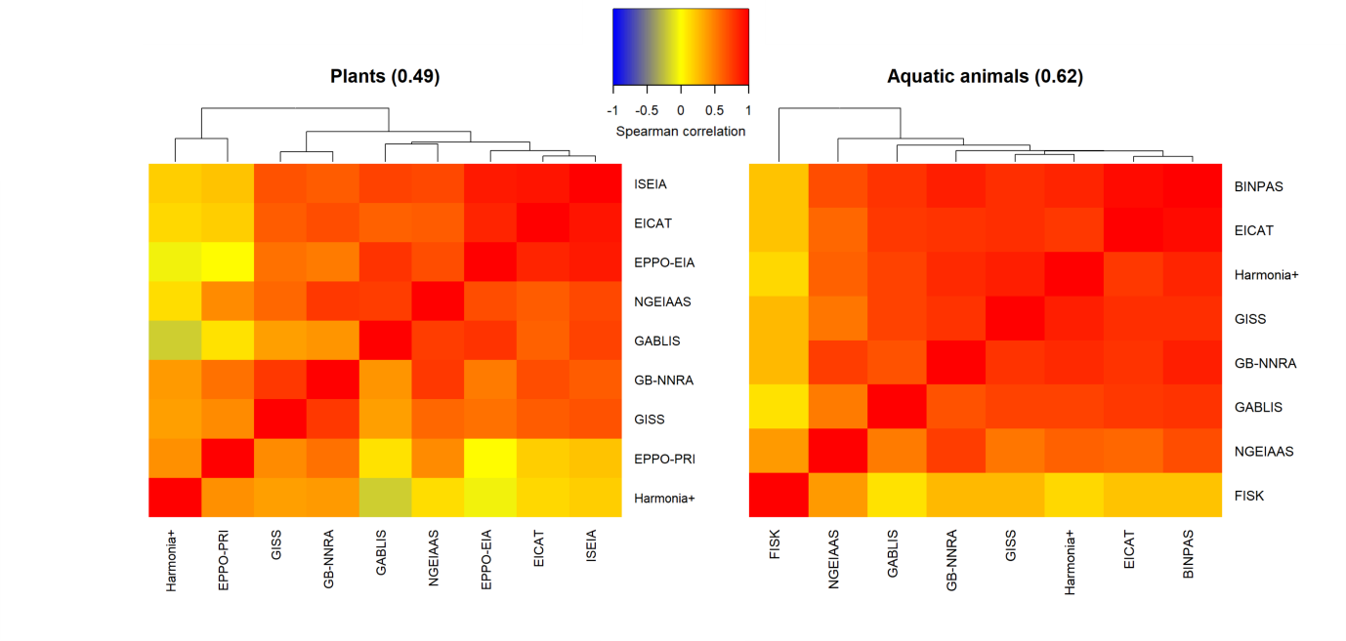

Table S1. List of non-native species considered in the study grouped by Taxonomic group indicating by columns: the number of independent assessments per protocol, the number of protocols considered for each species, the group with the same protocols considered (Group common protocols), the number of records in the Web of Science (WoS) using the accepted scientific name as a query (Records WoS), the mean and coefficient of variation (CV) of the level of expertise across the assessors that evaluated the species, the number of European countries where the species is considered established according to DASIE database, and whether the species is native to part of Europe (yes/no).
Species | Number assess. per protocol | Group common protocols | Records WoS | Mean expertise | CV expertise | Countries DAISIE | Native to part of Europe | Nu. Protocol | BINPAS | EICAT | EPPO-EIA |  |  | EPPO-PRI |  | FISK (et al.) |  | GABLIS |  |  | GB-NNRA |  |  | GISS |  |  | Harmonia+ |  |  | ISEIA |  |  | NGEIAAS
Freshwater fish
Australoheros facetus | 6 | Aquatic animals | 22 | 1.17 | 0.35 | 0 | No | 9 | x | x |  |  |  |  |  | x |  | x |  |  | x |  |  | x |  |  | x |  |  | x |  |  | x
Carassius auratus | 6 | Aquatic animals | 13767 | 2.33 | 0.22 | 8 | No | 9 | x | x |  |  |  |  |  | x |  | x |  |  | x |  |  | x |  |  | x |  |  | x |  |  | x
Oncorhynchus mykiss | 6 | Aquatic animals | 47437 | 2 | 0.32 | 0 | No | 9 | x | x |  |  |  |  |  | x |  | x |  |  | x |  |  | x |  |  | x |  |  | x |  |  | x
Freshwater invertebrates
Dikerogammarus villosus | 5 | Aquatic animals | 283 | 2 | 0.5 | 7 | No | 9 | x | x |  |  |  |  |  | x |  | x |  |  | x |  |  | x |  |  | x |  |  | x |  |  | x
Dreissena polymorpha | 5 | Aquatic animals | 6913 | 2.17 | 0.35 | 23 | Yes | 9 | x | x |  |  |  |  |  | x |  | x |  |  | x |  |  | x |  |  | x |  |  | x |  |  | x
Hemimysis anomala | 5 | Aquatic animals | 111 | 2 | 0.5 | 6 | No | 9 | x | x |  |  |  |  |  | x |  | x |  |  | x |  |  | x |  |  | x |  |  | x |  |  | x
Pomacea canaliculata | 5 | Aquatic animals | 654 | 1.6 | 0.56 | 0 | No | 8 | x | x |  |  |  |  |  | x |  | x |  |  | x |  |  | x |  |  | x |  |  | x |  |  | x
Procambarus clarkii | 5 | Aquatic animals | 6879 | 2 | 0.5 | 11 | No | 9 | x | x |  |  |  |  |  | x |  | x |  |  | x |  |  | x |  |  | x |  |  | x |  |  | x
Freshwater plants
Azolla filiculoides | 7 | Plants | 284 | 1.86 | 0.37 | 17 | No | 9 |  | x | x |  |  | x |  |  |  | x |  |  | x |  |  | x |  |  | x |  |  | x |  |  | x
Eichhornia crassipes | 6 | Plants | 1781 | 1.83 | 0.41 | 6 | No | 9 |  | x | x |  |  | x |  |  |  | x |  |  | x |  |  | x |  |  | x |  |  | x |  |  | x
Hydrocotyle verticillata | 6 | Plants | 11 | 1.5 | 0.37 | 1 | No | 9 |  | x | x |  |  | x |  |  |  | x |  |  | x |  |  | x |  |  | x |  |  | x |  |  | x
Myriophyllum heterophyllum | 8 | Plants | 44 | 1.5 | 0.36 | 2 | No | 9 |  | x | x |  |  | x |  |  |  | x |  |  | x |  |  | x |  |  | x |  |  | x |  |  | x
Pistia stratiotes | 7 | Plants | 572 | 1.43 | 0.55 | 3 | No | 9 |  | x | x |  |  | x |  |  |  | x |  |  | x |  |  | x |  |  | x |  |  | x |  |  | x
Insects
Aedes albopictus | 5 | Terr. invertebrates | 9803 | 1.8 | 0.25 | 19 | No | 7 |  | x |  |  |  |  |  |  |  | x |  |  | x |  |  | x |  |  | x |  |  | x |  |  | x
Anoplophora chinensis | 5 | Terr. invertebrates | 60 | 2 | 0.5 | 4 | No | 8 |  | x | x |  |  |  |  |  |  | x |  |  | x |  |  | x |  |  | x |  |  | x |  |  | x
Cameraria ohridella | 5 | Terr. invertebrates | 394 | 2.2 | 0.38 | 12 | No | 8 |  | x | x |  |  |  |  |  |  | x |  |  | x |  |  | x |  |  | x |  |  | x |  |  | x
Species | Number assess. per protocol | Group common protocols | Records WoS | Mean expertise | CV expertise | Countries DAISIE | Native to part of Europe | Nu. Protocol | BINPAS | EICAT | EPPO-EIA |  |  | EPPO-PRI |  | FISK (et al.) |  | GABLIS |  |  | GB-NNRA |  |  | GISS |  |  | Harmonia+ |  |  | ISEIA |  |  | NGEIAAS
Cydalima perspectalis | 5 | Terr. invertebrates | 52 | 2.17 | 0.19 | 10 | No | 8 |  | x | x |  |  |  |  |  |  | x |  |  | x |  |  | x |  |  | x |  |  | x |  |  | x
Diabrotica virgifera | 5 | Terr. invertebrates | 1202 | 1.8 | 0.61 | 16 | No | 8 |  | x | x |  |  |  |  |  |  | x |  |  | x |  |  | x |  |  | x |  |  | x |  |  | x
Drosophila suzukii | 7 | Terr. invertebrates | 219 | 1.67 | 0.31 | 6 | No | 8 |  | x | x |  |  |  |  |  |  | x |  |  | x |  |  | x |  |  | x |  |  | x |  |  | x
Dryocosmus kuriphilus | 5 | Terr. invertebrates | 218 | 2 | 0.5 | 7 | No | 8 |  | x | x |  |  |  |  |  |  | x |  |  | x |  |  | x |  |  | x |  |  | x |  |  | x
Harmonia axyridis | 6 | Terr. invertebrates | 1592 | 2.5 | 0.22 | 28 | No | 7 |  | x |  |  |  |  |  |  |  | x |  |  | x |  |  | x |  |  | x |  |  | x |  |  | x
Leptinotarsa decemlineata | 5 | Terr. invertebrates | 2941 | 1 | 0 | 38 | No | 8 |  | x | x |  |  |  |  |  |  | x |  |  | x |  |  | x |  |  | x |  |  | x |  |  | x
Leptoglossus occidentalis | 6 | Terr. invertebrates | 195 | 2 | 0.45 | 12 | No | 8 |  | x | x |  |  |  |  |  |  | x |  |  | x |  |  | x |  |  | x |  |  | x |  |  | x
Linepithema humile | 6 | Terr. invertebrates | 761 | 2 | 0.45 | 15 | No | 7 |  | x |  |  |  |  |  |  |  | x |  |  | x |  |  | x |  |  | x |  |  | x |  |  | x
Tuta absoluta | 5 | Terr. invertebrates | 446 | 1.8 | 0.46 | 26 | No | 8 |  | x | x |  |  |  |  |  |  | x |  |  | x |  |  | x |  |  | x |  |  | x |  |  | x
Vespa velutina | 6 | Terr. invertebrates | 129 | 1.17 | 0.35 | 1 | No | 7 |  | x |  |  |  |  |  |  |  | x |  |  | x |  |  | x |  |  | x |  |  | x |  |  | x
Marine
Caulerpa cylindracea | 5 | Algae | 107 | 2 | 0.5 | 11 | No | 7 | x | x |  |  |  |  |  |  |  | x |  |  | x |  |  | x |  |  | x |  |  |  |  |  | x
Conomurex persicus | 5 | Aquatic animals | 18 | 2 | 0.45 | 0 | No | 8 | x | x |  |  |  |  |  | x |  | x |  |  | x |  |  | x |  |  | x |  |  |  |  |  | x
Crepidula fornicata | 5 | Aquatic animals | 710 | 2.2 | 0.38 | 15 | No | 8 | x | x |  |  |  |  |  | x |  | x |  |  | x |  |  | x |  |  | x |  |  |  |  |  | x
Mnemiopsis leidyi | 5 | Aquatic animals | 813 | 2 | 0.5 | 6 | No | 8 | x | x |  |  |  |  |  | x |  | x |  |  | x |  |  | x |  |  | x |  |  |  |  |  | x
Percnon gibbesi | 5 | Aquatic animals | 71 | 2.2 | 0.38 | 4 | No | 8 | x | x |  |  |  |  |  | x |  | x |  |  | x |  |  | x |  |  | x |  |  |  |  |  | x
Plotosus lineatus | 5 | Aquatic animals | 89 | 1.5 | 0.56 | 1 | No | 8 | x | x |  |  |  |  |  | x |  | x |  |  | x |  |  | x |  |  | x |  |  |  |  |  | x
Rapana venosa | 5 | Aquatic animals | 287 | 1.8 | 0.61 | 5 | No | 8 | x | x |  |  |  |  |  | x |  | x |  |  | x |  |  | x |  |  | x |  |  |  |  |  | x
Rhopilema nomadica | 5 | Aquatic animals | 43 | 1.67 | 0.49 | 4 | No | 8 | x | x |  |  |  |  |  | x |  | x |  |  | x |  |  | x |  |  | x |  |  |  |  |  | x
Siganus luridus | 6 | Aquatic animals | 118 | 2.5 | 0.22 | 10 | No | 8 | x | x |  |  |  |  |  | x |  | x |  |  | x |  |  | x |  |  | x |  |  |  |  |  | x
Stephanolepis diaspros | 5 | Aquatic animals | 24 | 2 | 0.5 | 11 | No | 8 | x | x |  |  |  |  |  | x |  | x |  |  | x |  |  | x |  |  | x |  |  |  |  |  | x
Other terrestrial insects
Arion vulgaris (=lusitanicus) | 5 | Terr. invertebrates | 320 | 1.8 | 0.61 | 10 | Yes | 8 |  | x | x |  |  |  |  |  |  | x |  |  | x |  |  | x |  |  | x |  |  | x |  |  | x
Arthurdendyus triangulatus | 5 | Terr. invertebrates | 37 | 1 | 0 | 0 | No | 8 |  | x | x |  |  |  |  |  |  | x |  |  | x |  |  | x |  |  | x |  |  | x |  |  | x
Bursaphelenchus xylophilus | 5 | Terr. invertebrates | 1365 | 1 | 0 | 3 | No | 8 |  | x | x |  |  |  |  |  |  | x |  |  | x |  |  | x |  |  | x |  |  | x |  |  | x
Fascioloides magna | 5 | Terr. invertebrates | 298 | 1.4 | 0.64 | 2 | No | 8 |  | x | x |  |  |  |  |  |  | x |  |  | x |  |  | x |  |  | x |  |  | x |  |  | x
Species | Number assess. per protocol | Group common protocols | Records WoS | Mean expertise | CV expertise | Countries DAISIE | Native to part of Europe | Nu. Protocol | BINPAS | EICAT | EPPO-EIA |  |  | EPPO-PRI |  | FISK (et al.) |  | GABLIS |  |  | GB-NNRA |  |  | GISS |  |  | Harmonia+ |  |  | ISEIA |  |  | NGEIAAS
Pathogens
Hymenoscyphus fraxineus | 5 | Pathogen | 78 | 2 | 0.45 | 0 | No | 8 |  | x | x |  |  |  |  |  |  | x |  |  | x |  |  | x |  |  | x |  |  | x |  |  | x
Phytophthora alni | 6 | Pathogen | 47 | 2.17 | 0.19 | 19 | No | 8 |  | x | x |  |  |  |  |  |  | x |  |  | x |  |  | x |  |  | x |  |  | x |  |  | x
Phytophthora plurivora | 7 | Pathogen | 30 | 1.86 | 0.37 | 0 | No | 8 |  | x | x |  |  |  |  |  |  | x |  |  | x |  |  | x |  |  | x |  |  | x |  |  | x
Terrestrial plants
Acacia dealbata | 5 | Plants | 182 | 2 | 0.35 | 8 | No | 9 |  | x | x |  |  | x |  |  |  | x |  |  | x |  |  | x |  |  | x |  |  | x |  |  | x
Ambrosia artemisiifolia | 8 | Plants | 1049 | 2.25 | 0.31 | 14 | No | 9 |  | x | x |  |  | x |  |  |  | x |  |  | x |  |  | x |  |  | x |  |  | x |  |  | x
Baccharis halimifolia | 5 | Plants | 103 | 1.6 | 0.56 | 5 | No | 9 |  | x | x |  |  | x |  |  |  | x |  |  | x |  |  | x |  |  | x |  |  | x |  |  | x
Cortaderia selloana | 5 | Plants | 53 | 1.8 | 0.46 | 8 | No | 9 |  | x | x |  |  | x |  |  |  | x |  |  | x |  |  | x |  |  | x |  |  | x |  |  | x
Heracleum mantegazzianum | 6 | Plants | 175 | 2 | 0.45 | 17 | No | 9 |  | x | x |  |  | x |  |  |  | x |  |  | x |  |  | x |  |  | x |  |  | x |  |  | x
Lupinus polyphyllus | 5 | Plants | 178 | 1.4 | 0.39 | 16 | No | 9 |  | x | x |  |  | x |  |  |  | x |  |  | x |  |  | x |  |  | x |  |  | x |  |  | x
Opuntia ficus-indica | 6 | Plants | 1604 | 2 | 0.32 | 12 | No | 9 |  | x | x |  |  | x |  |  |  | x |  |  | x |  |  | x |  |  | x |  |  | x |  |  | x
Robinia pseudoacacia | 6 | Plants | 1583 | 2.33 | 0.22 | 32 | No | 9 |  | x | x |  |  | x |  |  |  | x |  |  | x |  |  | x |  |  | x |  |  | x |  |  | x
Sicyos angulatus | 5 | Plants | 49 | 1.8 | 0.46 | 3 | No | 9 |  | x | x |  |  | x |  |  |  | x |  |  | x |  |  | x |  |  | x |  |  | x |  |  | x
Solanum elaeagnifolium | 5 | Plants | 146 | 1.4 | 0.39 | 6 | No | 9 |  | x | x |  |  | x |  |  |  | x |  |  | x |  |  | x |  |  | x |  |  | x |  |  | x
Terrestrial vertebrates
Lithobates catesbeianus | 5 | Terr. Vertebrates | 380 | 1.8 | 0.46 | 8 | No | 7 |  | x |  |  |  |  |  |  |  | x |  |  | x |  |  | x |  |  | x |  |  | x |  |  | x
Psittacula krameri | 5 | Terr. Vertebrates | 500 | 1.6 | 0.34 | 18 | No | 7 |  | x |  |  |  |  |  |  |  | x |  |  | x |  |  | x |  |  | x |  |  | x |  |  | x
Threskiornis aethiopicus | 6 | Terr. Vertebrates | 119 | 1.33 | 0.39 | 2 | No | 7 |  | x |  |  |  |  |  |  |  | x |  |  | x |  |  | x |  |  | x |  |  | x |  |  | x
Trachemys scripta | 5 | Terr. Vertebrates | 1612 | 1.6 | 0.34 | 15 | No | 7 |  | x |  |  |  |  |  |  |  | x |  |  | x |  |  | x |  |  | x |  |  | x |  |  | x

Abbreviations. Terr.: terrestrial; WoS: Web of Science; CV: Coefficient of Variation
Table S2. Pearson correlation coefficients among the continuous variables used in the regression analyses to explain the coefficient of variation of scores across assessors with species and protocol characteristics. Significance values: **P<0.01, *** P<0.001
 | Number of questions | Records WoS | Expertise required | Mean assessor expertise
Records WoS | 0.04
Expertise required | 0.51*** | 0.03
Mean assessor expertise | 0.05 | 0.15** | 0.05
CV assessor expertise | 0.04 | -0.16*** | 0.03 | 0.09*
WoS: Web of Science; CV: Coefficient of Variation

