Appendix 1
Table S1
Classification of the types of costs (“Type of cost” column in the InvaCost database) into “damage” (economic losses due to direct and/or indirect impacts of invaders), “management” (monetary resources allocated to mitigate the spread and/or impacts of invaders), or “mixed” (when costs correspond both previous categories simultaneously). We assigned unspecified when the nature of cost was not defined.
Damage_costs | 690
Damage repair | 3
Damage-Loss | 586
Damage-Loss/Medical | 1
Indirect costs | 46
Indirect costs (not detailed) | 13
Medical | 1
Medical care | 39
Subsidy for damage-loss Insurance | 1
Management_costs | 1273
Communication/Control/Research | 6
Control | 540
Control/Eradication | 40
Control/Eradication/Information/Prevention | 1
Control/Eradication/Research | 15
Control/Maintenance | 1
Control/Management | 17
Control/Monitoring | 9
Control/Prevention | 33
Control/Research | 1
Control/Research/Surveillance | 30
Control/Surveillance | 9
Detection/Education/Outreach/Regulation/Research | 1
Early detection/Information | 3
Early detection/Prevention | 1
Education | 8
Eradication | 376
Eradication/Surveillance | 1
Funding | 29
Household use of insecticide | 1
Management | 29
Management (Unspecified) | 3
Management/Prevention | 1
Mitigation | 1
Monitoring | 14
Outreach | 8
Prevention | 29
Prevention/Research | 1
Research | 30
Surveillance | 35
Mixed_costs | 69
Control/Damage-Loss | 63
Control/Damage-Loss/Management | 2
Control/Damage-Loss/Prevention | 2
Damage-Loss/Management | 2
Unspecified | 90
Unspecified | 90
Total | 2122

Table S2
Search terms used to match invasive species that have economic impacts in North America to pathways of introduction from CABI.

Pathway type | Linked Pathways
Pet Trade | “Pet trade”, “Aquarium trade”, “Botanical gardens and zoos”, “Horticulture”, “Ornamental purposes”, “ Cut flower trade”, “Nursery trade“
Agriculture | “Animal production”, “Seed trade”, “crop production”, “Live food or feed trade“, “ Food”
Forestry | “Timber trade”, “Forestry”
Fisheries | “Stocking”, “Hunting, Angling, Sport or Racing”, “Fisheries”, “Aquaculture”
Health | “Medicinal use“

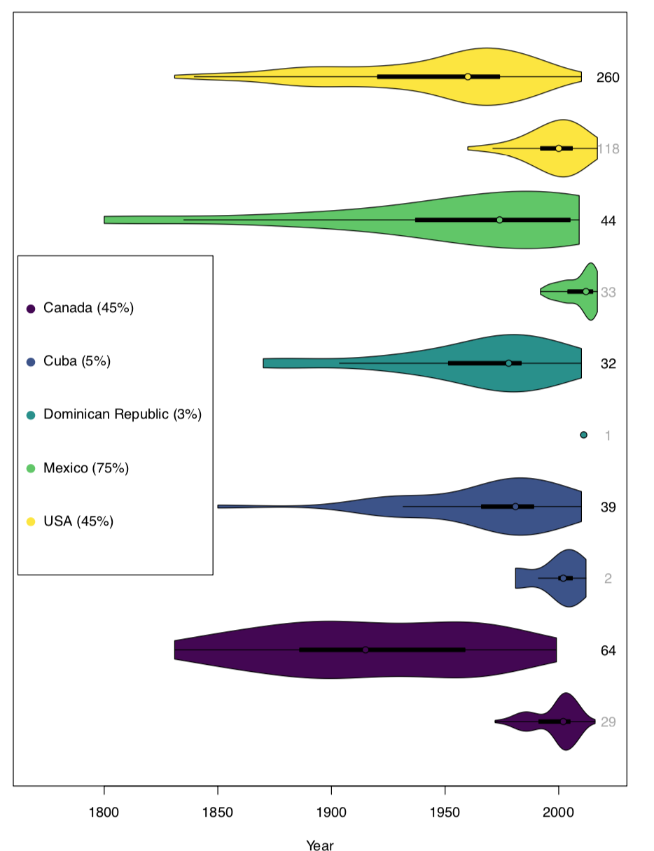
Figure S1
Comparison of the timeline of establishment records of invasive species within the sTwist database (upper violin plots, black species counts) and records of species economic costs within our robust subset of InvaCost (lower violin plots, grey species counts) over time. Relative completeness of InvaCost in terms of numbers of species is shown as a percentage in the legend. For sTwist, the number of establishment records was 439 after removal of invaders prior to 1800 (n = 21). One species may be described by multiple years of InvaCost records (as is the case for the single species recorded in our robust subset in Cuba).

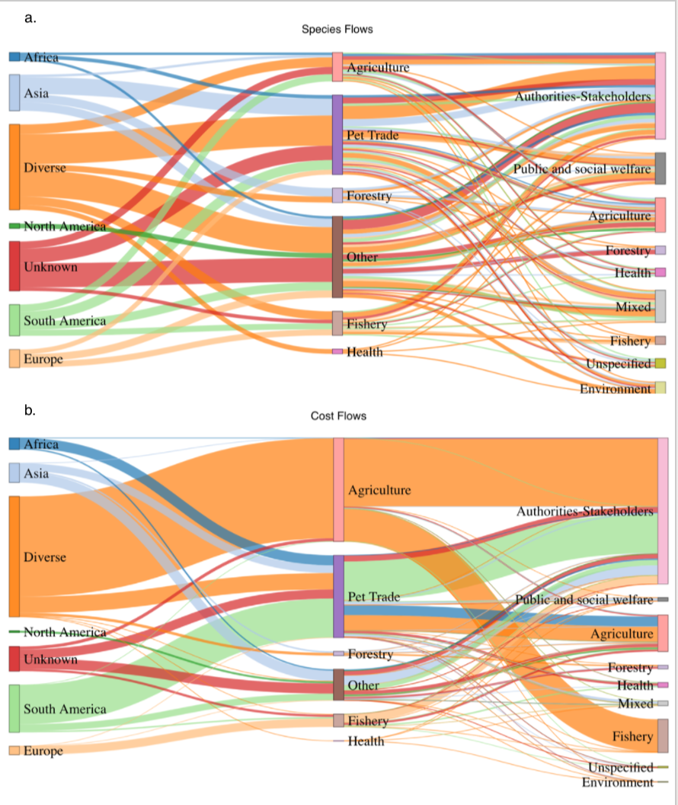Figure S2
Flows from pathways of entry to impacted sectors proportional to a) the number of species originating from each continent (including unknown and diverse origins), and b) to the costs incurred estimated from our robust dataset (2017 US$). Originating nodes and colored flows in this diagram correspond to the continent of origin of each species when available from CABI. The center node labels correspond to dominant entry pathways characterized by CABI (n = 88 species with pathway information), while the destination node labels correspond to impacted sectors within the robust dataset.

