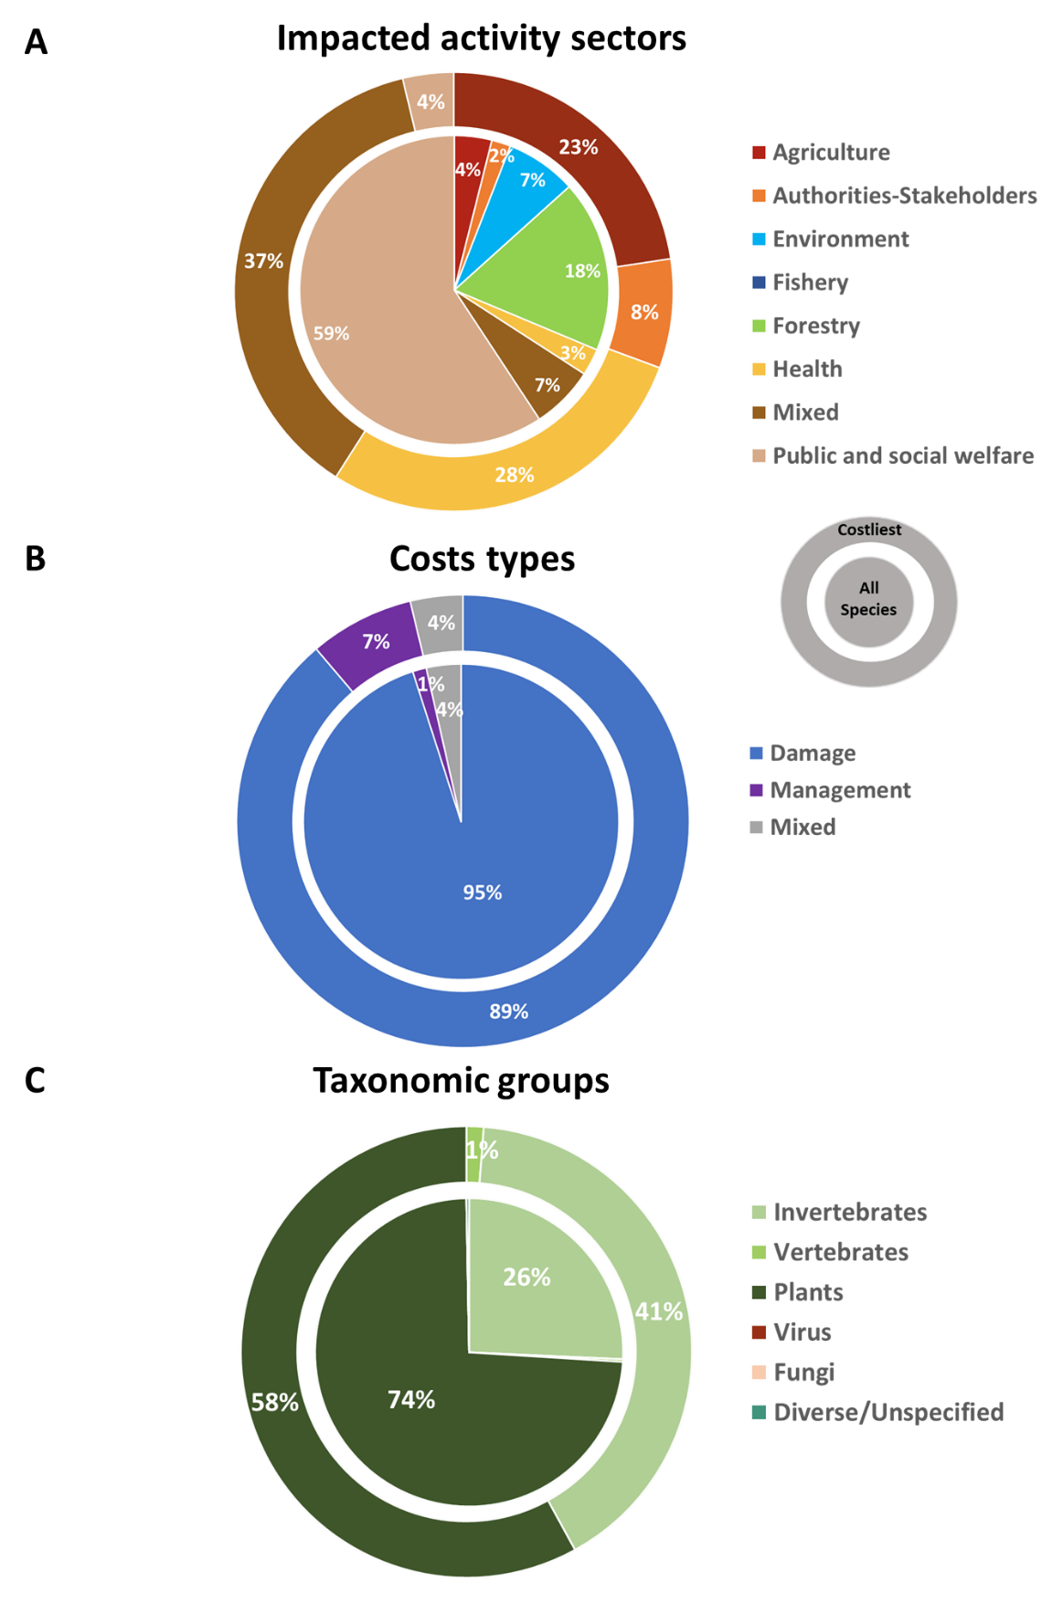
Supplementary File 6. Categorical representation of the cumulated costs caused by invasive alien species in metropolitan France and French overseas over the period 1993-2018 per (a) activity sectors, (b) cost types, and (c) taxonomic groups. Pie charts show the cost contribution of alien invasive species to the different categories; inner circle shows information based on all costs (i.e. observed and potential costs), whereas the outer circle restricts the information to the costliest invaders (i.e. observed costs > 1 US$ million) from France (Aedes spp., Ambrosia spp., Lagorasiphon major, Lithobates catesbeianus, Ludwigia spp., Procambarus clarkii, Rattus spp., Reynoutria spp., Rusa timorensis, Vespa velutina, Felis catus, Baccharis halimifolia) is presented in the surrounding circle.

