Supplementary file A: The questionnaire (1 block of 3 is presented hereafter)

IDENTIFICATION OF THE QUESTIONNAIRE: BLOCK 1

ID : --------------------------------------------------------------------------------------/ ---- ---- ------
Province : ---------------------------------------------------------------------------------------/ ----
City : ---------------------------------------------------------------------------------------/ ----
Location : --------------------------------------------------------------------------------------/ ----
Date : ------ / ------ /-----
Hour : ------ h ------

Section I:
Respondents’ opinions on Apulia’s olive landscape

This section includes attitudinal questions dealing with individuals’ general attitudes towards the olive landscape and its benefits, and their knowledge of the multi-functionality of the olive sector in Apulia. At the end of this part, interviewees are informed about the current epidemic of olive quick decline syndrome caused by Xylella fastidiosa that deprives gradually the Apulia landscape of its historical, patrimonial and cultural element: the olive trees. Relevant photos will support this section.
- Which of the following activities have you usually done in your free time, at least once in the Apulia region over the last 12 months?

1: □ swimming and/or fishing
2: □ visiting olive farms and/or eating in their local restaurants also with family
3: □ walking or jogging near an olive landscape
4: □ observing the natural landscape, historical buildings
5: □ none of the above mentioned activities
6: □ other (optional): ------------------------------------------------------------------------------------------

- How often have you been (or do you go) to the south of Apulia?

1: □ I live there
2: □ more than once a week;
3: □ several times over the course of one year
4: □ never in the last 7 years

- How important do you consider the presence of olive trees in Apulia’s landscape?

1: □ very important
2: □ quite important
3: □ of little importance
4: □ not at all important
5: □ I don’t know

- Please express your degree of agreement with each of the following sentences (ranging from “I strongly agree” to “I strongly disagree”)

  - The olive landscape provides economic benefits
1: □ I strongly agree
2: □ I agree
3: □ l slightly agree
4: □ I strongly disagree
5: □ I don’t know

4.2. The olive landscape provides social benefits
1: □ I strongly agree
2: □ I agree
3: □ l slightly agree
4: □ I strongly disagree
5: □ I don’t know

4.3. The olive landscape produces food
1: □ I strongly agree
2: □ I agree
3: □ l slightly agree
4: □ I strongly disagree
5: □ I don’t know

4.4. The olive landscape represents an important cultural heritage & an aesthetic value
1: □ I strongly agree
2: □ I agree
3: □ l slightly agree
4: □ I strongly disagree
5: □ I don’t know

4.5. The olive landscape represents an important field of research and experimentation
1: □ I strongly agree
2: □ I agree
3: □ l slightly agree
4: □ I strongly disagree
5: □ I don’t know

4.6. The olive landscape has a positive environmental effect
1: □ I strongly agree
2: □ I agree
3: □ l slightly agree
4: □ I strongly disagree
5: □ I don’t know
Interviewer: As you may know, since 2013, olive farmers in the Apulia region have been facing the olive quick decline epidemic caused by Xylella fastidiosa. It progressively deprives the region of its distinctive landscape.
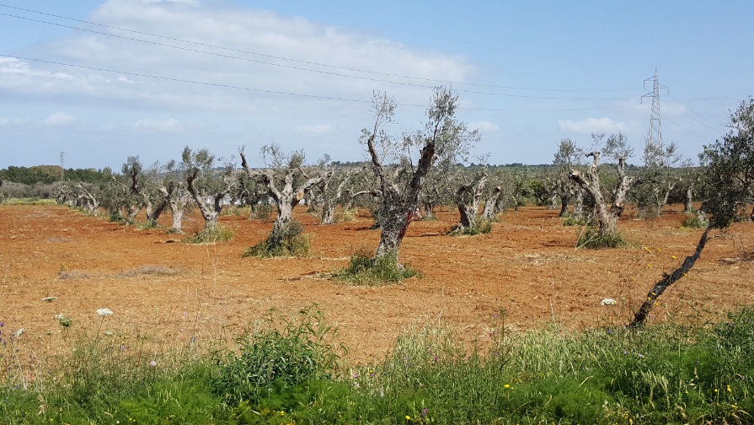
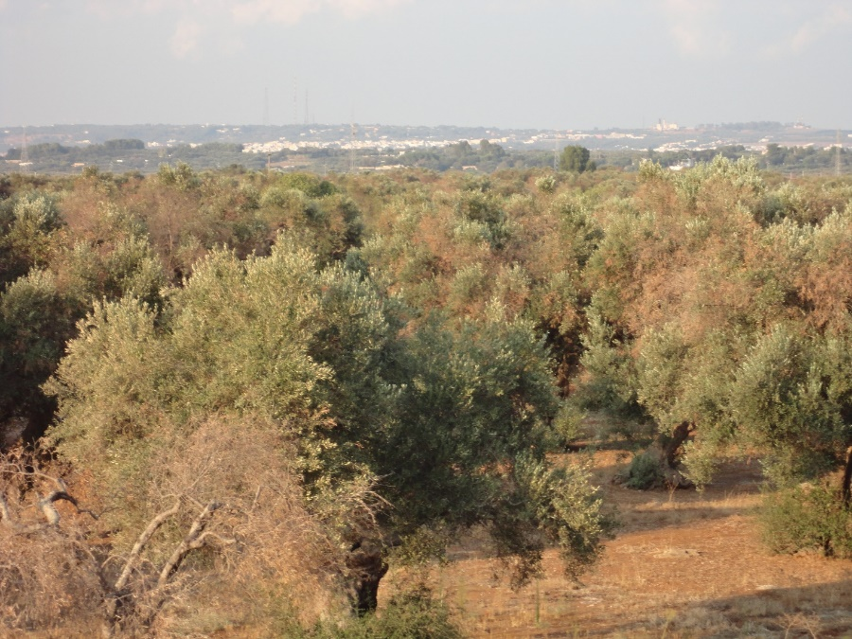
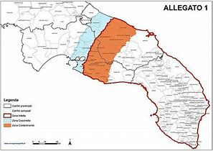
Section II:
Apulia citizens’ preferences for the improvement of THE affected landscape
As described above, many experts believe that it is vital and necessary to restore the affected landscapes in Apulia. However, the spread of Xylella fastidiosa has already placed this landscape at high risk. To date, most olive orchards in the south of the region are already degenerated with negative consequences for the economic, social, cultural and environmental elements. In addition, this landscape is likely to disappear in other areas of Apulia due to the gradual progress of the epidemic from the south to the north of the Apulia region.
Now that you have a clearer idea of the situation, we kindly ask you to make choices regarding possible activities aimed at restoring the compromised landscape. Your help is indispensable in the goal of restoring the affected landscape in the best interests of all Apulia’s citizens.
The following areas of improvement are essential parts of the study. We are very keen to know - from you - which are the most relevant.
Area of improvement: Form of the future landscape:
- Landscape not restored, as it is currently, characterized by the presence of diseased olives trees;
- Landscape with resistant-Xf olive cultivars only through a traditional system of production;
- Landscape with Resistant-Xf olive cultivars only through an intensive system of production;
- Landscape with Resistant-Xf olive cultivars only through a dispersal/sparse system of production;
- Landscape planted with mixed productive crops (vineyards, pomegranate, stone fruits)
- Landscape planted mixed productive crops and bushes
Area of improvement: Research & Experimentation
The possibility of producing resistant Xylella cultivars, as well as to find a cure.
Additional cost: Amount of the tax, lasting 10 years, to finance the restoration of the landscape in Apulia (€) as follows:
- 0 euros/household/year (for the next 10 years)
- 15 euros/household/year (for the next 10 years)
- 30 euros/household/year (for the next 10 years)
- 60 euros/household/year (for the next 10 years)
- 90 euros/household/year (for the next 10 years)
For this reason, I will present you some options. Each option represents a strategy made of a combination of the above mentioned areas of improvement and additional cost. Options form a table.
There are 4 tables. I ask you to indicate the option that you most welcome to ensure the restoration of the affected landscapes in south Apulia. The first table is on page 7.
As you can see, a table consists of 4 columns. The first column describes the areas of improvement to guarantee the availability of the landscape for today’s citizens and for future generations. The next three columns concern the 3 different strategies that could be chosen.
These are referred to as: "Status quo", "Alternative A" and "Alternative B".
All you have to do is to choose the action plan that you most prefer among the 3 presented for each table. The financial resources needed to adopt the alternatives will be collected through a new regional tax. In fact, the third-last row in the table contains the amount of money you would have to pay annually for the next 10 years, depending on your chosen action plan.
So, in the example table shown, Alternative A will cost you 0 per year, for the next 10 years, while Alternative B will cost you 90 euros a year, again for the next 10 years. The Status quo will not cost you anything, as it does not provide funding.
I remind you that if you choose an action plan that does not foresee the payment of any tax devoted to restoring the landscape in Apulia, that the landscape in question will no longer be available to future generations.
You will have to fill out 4 tables, in each of which the "Status quo" will always be the same, while the other two will vary. At this point we want to specify a very important aspect: in making the choice for each table, we ask you to seriously consider the possibility of paying the amount of tax to ensure the restoration of the landscape in Apulia. This means that in choosing the most preferred action plan, you will have to compare the amount of the chosen tax with your financial resources. In other words, if you are interested in restoring the landscape and therefore prefer the option A or B, but the tax reported is too high, then the least expensive option will automatically be selected even if this does not restore the landscape.
In summary, I remind you of some important concepts that must be kept firmly in mind during the compilation. Remember:
- that the investigation concerns the restoration of the landscape at risk of extinction;
- that the alternatives (A, B) aim to have another form of the landscape compared to the situation today;
- to consider the real possibility of paying the tax reported for the alternative you choose, based on your financial capabilities.
We say this because other similar investigations have established that people tend to respond differently to how they would actually act in reality. For example, it is very common for people to choose an action plan whose implementation requires a higher tax than they would – in reality – find feasible. This is because in such situations people want to appear generous, choosing the most expensive option and so guaranteeing the best results. However, such a strategy would bias the study.
Finally, at the end of each table you will be asked for your degree of certainty for the choice you made and, once you have completed all 4 tables, you will be asked the reasons behind the choices you made.
SET OF CHOICE N° 1:
Area of  Improvement | Status quo | Alternative A | Alternative B
Landscape | No improvement:  Like now  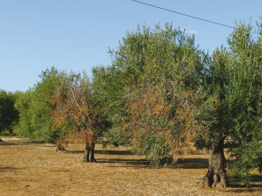 | Olive:  Traditional system  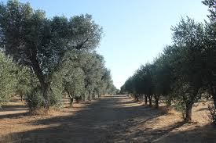 | Mixed:  Productive crops & Bushes  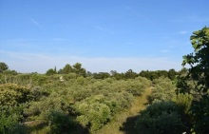
Research | Yes | No | Yes
Additional cost  (for the next 10 years) | 0 euros/years | 0 euros/years | 90 euros/year
Which do you prefer? | □ | □ | □
How certain are you about your choice? | 1: □ Absolutely certain  2: □ Quite certain  3: □ Not very  4: □ Completely uncertain
SET OF CHOICE N° 2:
Area of  Improvement | Status quo | Alternative A | Alternative B
Landscape | No improvement:  Like now  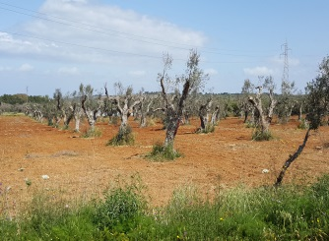 | Mixed:  Productive crops & Bushes | Olive:  Traditional system  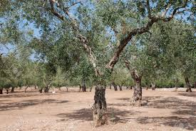
Research | Yes | Yes | No
Additional cost  (for the next 10 years) | 0 euros/years | 0 euros/years | 30 euros/year
Which do you prefer? | □ | □ | □
How certain are you about your choice? | 1: □ Absolutely certain  2: □ Quite certain  3: □ Not very certain  4: □ Completely uncertain
SET OF CHOICE N° 3:
Area of  Improvement | Status quo | Alternative A | Alternative B
Landscape | No improvement:  Like now | Mixed:  Productive crops & Bushes | Olive:  Traditional system
Research | Yes | No | Yes
Additional cost  (for the next 10 years) | 0 euros/years | 15 euros/years | 15 euros/year
Which do you prefer? | □ | □ | □
How certain are you about your choice? | 1: □ Absolutely certain  2: □ Quite certain  3: □ Not very certain  4: □ Completely uncertain
SET OF CHOICE N° 4:
Area of  Improvement | Status quo | Alternative A | Alternative B
Landscape | No improvement:  Like now | Olive:  Intensive system  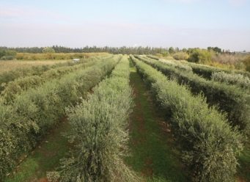 | Mixed:  Productive crops  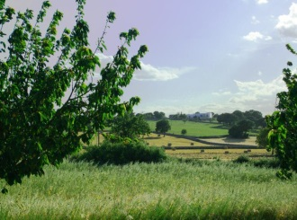
Research | Yes | Yes | No
Additional cost  (for the next 10 years) | 0 euros/years | 0 euros/years | 90 euros/year
Which do you prefer? | □ | □ | □
How certain are you about your choice? | 1: □ Absolutely certain  2: □ Quite certain  3: □ Not very certain  4: □ Completely uncertain
Which of the following statements best describes how you made your choices?

- □ I randomly chose
- □ I have chosen the “Status quo” because I do not believe in the restoration of the olive landscapes
- □ I chose the “Status quo” since I don't want to pay additional fees
- □ I did not choose the “Status quo” option because I do not wish to see the disappearance of Apulian landscape
- □ I chose the cheapest alternative
- □ I chose the alternative that ensured the greatest relationship between benefits and costs in the restoration of the landscape in Apulia
- □ I chose the action plan that ensured the greatest benefits, regardless of the cost of restoring the landscape
- □ I chose the “Status quo” because I am in favor of voluntary contribution (not obligatory)
- □ I chose the cheapest action plan since I don't have enough information on the topic
- □ Other (specify): ------------------------------------------------------------------------------

Section III:
Socio-economic characteristics of respondents
I remind you that on the basis of the laws on privacy, all the information that you provide will be anonymous and used exclusively for the purposes of this research.
- May I ask you your age? _____________

- Gender:
1: □ Male
2: □ Female

- Where do you live? The name?
1: □ Rural: ---------------------------------------------------------------------
2: □ Urban: --------------------------------------------------------------------

- How many people live in your family?
1: □ 1
2: □ 2
3: □ 3
4: □ 4
5: □ more than 4

- How many family members are under 18 years old? --------------

- May I ask your level of education?
1: □ Not educated
2: □ Elementary school diploma
3: □ Lower secondary school diploma
4: □ High secondary school diploma
5: □ University

- Are you currently employed?
1: □ Yes
2: □ No

- What best describes your current occupation/position?
1: □ Farmer
2: □ Entrepreneur
3: □ Dependent employee
4: □ Free-lance
5: □ Manual worker
6: □ Student
7: □ Taking care of own household
8: □ Retired
9: □ other (specify): ----------------------------------------------------------------------
- Sector of your activity:
1: □ Agriculture
2: □ Commerce
3: □ Communication
4: □ Finance/insurance
5: □ Army/security
6: □ Construction
7: □ Industry
8: □ Education
9: □ Transport
10: □ Tourism
11: □ other (specify): ----------------------------------------------------------------------

- Are you member of any nature, agriculture and/or environment organization?
1: □ Yes
2: □ No

- Did you or someone in your household own an olive farm?
1: □ Yes, surface: -------- Ha
2: □ No

- Household’s annual gross income (in 1000 Euros, before taxation)
1: □ < 20
2: □ between 20 and 60
3: □ > 60

THANK YOU FOR YOUR ANSWERS!

