Supplementary materials
Tables
Table S1. Incubator temperatures (IT in °C) at which Harmonia axyridis performed best in terms of reproduction and population growth characteristics (R₀ = net reproductive rate; T = mean generation time; r = intrinsic rate of natural increase; λ = finite rate of population increase; DT = population doubling time). Best performance defined as either “lowest” or “highest” response values is however dependent on the environmental conditions and season of the region studied (e.g. depending on context and season, higher developmental time can be advantageous). Incubator temperatures represent the temperatures tested in each study. Multiple temperatures listed per trait indicates that there were no significant differences in the trait of interest across temperatures.
Incubator temperatures (IT in °C) | IT of lowest developmental time (°C) | IT of lowest pre-oviposition period (°C) | IT of highest oviposition period (°C) | IT of highest longevity (°C) | IT of highest fecundity (°C) | IT of highest survival % (egg/larva-pupa/adult) (°C) | IT of lowest mortality % | IT of highest R₀ | IT of lowest T | IT of highest r | IT of highest λ | IT of lowest DT | Reference
15, 20, 25 | 25 | 15, 20, 25 | 15, 20, 25 | 15, 20, 25 | 15 |  |  | 15 | 25 | 25 | 25 | 25 | Castro et al. 2011
18, 21, 24, 27, 30 | 27, 30 | 27, 30 | 18, 21, 24, 27 | 18, 21, 24 |  | 18, 24, 27 |  |  |  |  |  |  | de Oliveira Ramos et al. 2014
10, 14, 18, 22, 26,30, 34 | 30 |  |  |  |  |  | 22, 26 |  |  |  |  |  | LaMana & Miller 1998
17.8, 20.8 | 20.8 |  |  |  |  |  | 20.8 |  |  |  |  |  | Krengel et al. 2012
15, 20, 25, 30 | 30 | 25, 30 |  |  |  |  |  |  |  |  |  |  | Stathas et al. 2011
25, 37, 39, 41 | 25, 37, 39 | 25 | 25 | 25 | 25 | 25 | 25 |  |  |  |  |  | Zhang et al. 2014
20, 24, 30, 33 | 30 |  |  |  | 24 | 20 |  |  |  |  |  |  | Barahona-Segovia et al. 2016
Average | 29.4 | 24.6 | 21.9 | 21.1 | 21.3 | 22.8 | 23.5 | 15 | 25 | 25 | 25 | 25
SD | 5.5 | 5 | 4.1 | 3.8 | 5.5 | 3.7 | 2.5
The lower developmental threshold for H. axyridis varied from 10.8 to 12.4°C (egg to adult) (de Oliveira Ramos et al. 2014; LaMana and Miller 1998; Stathas et al. 2011). Harmonia axyridis eggs did not hatch at 10°C (LaMana & Miller 1998), 33°C (Barahona-Segovia et al. 2016), 34°C (LaMana & Miller 1998) and 41°C (Zhang et al. 2014).

Table S2. Harmonia axyridis and Cheilomenes lunata collection sites (GPS coordinates) in Stellenbosch (Western Cape Province, South Africa).
Site | Latitude | Longitude
Stellenbosch CBD | 34°91'60.13"S | 18°86'42.12"E
Die Bergkelder | 33°56'3.35"S | 18°51'6.24"E
Avontuur Wine Estate | 34°1'35.61"S | 18°49'20.61"E
Oude Libertas | 33°94'00.48"S | 18°83'80.01"E
Spice Route | 33°46'9.54"S | 18°55'3.72"E
Ride-in | 33°94'17.47"S | 18°90'4.25"E
Postcard Café | 33°57'14.44"S | 18°54'37.89"E
Ludwig's Rose Farm | 33°49'37.22"S | 18°47'41.70"E
Slaley Wine Farm | 33°51'56.90"S | 18°50'51.39"E
Kanonkop Winery | 33°51'7.88"S | 18°51'27.73"E

Table S3. Best model outputs for each trait: (a) Starvation resistance, (b) CT_{min}, (c) CT_{max}, (d) preoviposition period, (e) total eggs laid, (f) hatching success, (g) developmental time, (h) pupal emergence success, (i) adult mass, and (j) intrinsic rate of increase. Terms with significant parameter estimates shown in bold. Two tables are presented for each trait: the first table is the model output with the cold temperature as the reference treatment; the second table is with the Medium treatment as the reference level (reference levels were changed to test for significant slope differences between interacting terms). HA = Harmonia axyridis, CL: Cheilomenes lunata.

- Starvation resistance
Full model: Starvation resistance ~ Mass loss*Sex*Species*Treatment + (1|Family_ID)
Fixed effect | Estimate | SE | z value | P value
Mass_loss | -0.01 | 0.02 | -0.50 | 0.62
SexMale | 0.37 | 0.62 | 0.60 | 0.55
SpeciesHA | 0.68 | 0.38 | 1.78 | 0.08
Temp_treatMedium | 3.04 | 0.69 | 4.43 | 9.60E-06
Temp_treatWarm | 4.14 | 0.71 | 5.87 | 4.30E-09
Mass_loss:SexMale | 0.04 | 0.04 | 1.12 | 0.26
Mass_loss:Temp_treatMedium | -0.02 | 0.03 | -0.72 | 0.47
Mass_loss:Temp_treatWarm | 0.05 | 0.03 | 1.67 | 0.10
SexMale:Temp_treatMedium | -0.60 | 0.87 | -0.69 | 0.49
SexMale:Temp_treatWarm | 0.89 | 0.87 | 1.02 | 0.31
SpeciesHA:Temp_treatMedium | -0.55 | 0.40 | -1.36 | 0.17
SpeciesHA:Temp_treatWarm | -1.16 | 0.37 | -3.16 | 0.002
Mass_loss:SexMale:Temp_treatMedium | 0.03 | 0.05 | 0.52 | 0.61
Mass_loss:SexMale:Temp_treatWarm | -0.13 | 0.05 | -2.80 | 0.01

Fixed effect | Estimate | SE | z value | P value
Mass_loss | -0.04 | 0.02 | -1.47 | 0.14
SexMale | -0.23 | 0.59 | -0.38 | 0.70
SpeciesHA | 0.12 | 0.41 | 0.30 | 0.76
Temp_treatCold | -3.04 | 0.69 | -4.43 | 9.60E-06
Temp_treatWarm | 1.11 | 0.71 | 1.57 | 0.12
Mass_loss:SexMale | 0.07 | 0.03 | 2.00 | 0.05
Mass_loss:Temp_treatCold | 0.02 | 0.03 | 0.72 | 0.47
Mass_loss:Temp_treatWarm | 0.08 | 0.03 | 2.37 | 0.02
SexMale:Temp_treatCold | 0.60 | 0.87 | 0.69 | 0.49
SexMale:Temp_treatWarm | 1.48 | 0.85 | 1.74 | 0.08
SpeciesHA:Temp_treatCold | 0.55 | 0.40 | 1.36 | 0.17
SpeciesHA:Temp_treatWarm | -0.61 | 0.39 | -1.54 | 0.12
Mass_loss:SexMale:Temp_treatCold | -0.03 | 0.05 | -0.52 | 0.61
Mass_loss:SexMale:Temp_treatWarm | -0.16 | 0.05 | -3.53 | 0.0004

- CT_{min}
Full model: CT_{min} ~ Mass*Sex*Species*Treatment + (1|Family_ID)
Variance structures: Species, Treatment
Fixed effect | Estimate | SE | t value | P value
(Intercept) | 1.29 | 0.38 | 3.37 | <0.001
Mass | -0.04 | 0.01 | -2.92 | 0.004
Temp_treatMedium | 0.41 | 0.21 | 1.93 | 0.060
Temp_treatWarm | 0.64 | 0.19 | 3.38 | <0.001

Fixed effect | Estimate | SE | t value | P value
(Intercept) | 1.70 | 0.39 | 4.41 | <0.0001
Mass | -0.04 | 0.01 | -2.92 | 0.004
Temp_treatCold | -0.41 | 0.21 | -1.93 | 0.060
Temp_treatWarm | 0.23 | 0.19 | 1.20 | 0.23

- CT_{max}
Full model: CT_{max} ~ Mass*Sex*Species*Treatment + (1|Family_ID)
Variance structures: Species, Treatment
Fixed effect | Estimate | SE | t value | P value
(Intercept) | 45.04 | 0.38 | 120.06 | 0.000
Mass | 0.004 | 0.018 | 0.23 | 0.82
SexMale | -1.51 | 0.48 | -3.13 | 0.002
SpeciesHA | -1.17 | 0.48 | -2.46 | 0.02
Temp_treatMedium | 0.31 | 0.10 | 3.03 | 0.003
Temp_treatWarm | 0.77 | 0.11 | 6.84 | 0.000
Mass:SexMale | 0.08 | 0.02 | 3.30 | 0.001
Mass:SpeciesHA | 0.02 | 0.02 | 0.82 | 0.41
SexMale:SpeciesHA | 2.00 | 0.60 | 3.31 | 0.001
SexMale:Temp_treatMedium | -0.26 | 0.14 | -1.82 | 0.07
SexMale:Temp_treatWarm | -0.37 | 0.15 | -2.46 | 0.015
Mass:SexMale:SpeciesHA | -0.09 | 0.03 | -3.07 | 0.002

Fixed effect | Estimate | SE | t value | P value
(Intercept) | 45.36 | 0.37 | 122.54 | 0.000
Mass | 0.004 | 0.018 | 0.232 | 0.82
SexMale | -1.76 | 0.47 | -3.74 | 0.0002
SpeciesHA | -1.17 | 0.48 | -2.46 | 0.02
Temp_treatCold | -0.31 | 0.10 | -3.03 | 0.003
Temp_treatWarm | 0.46 | 0.11 | 4.02 | 0.0001
Mass:SexMale | 0.08 | 0.02 | 3.30 | 0.001
Mass:SpeciesHA | 0.02 | 0.02 | 0.82 | 0.41
SexMale:SpeciesHA | 2.00 | 0.60 | 3.31 | 0.001
SexMale:Temp_treatCold | 0.26 | 0.14 | 1.82 | 0.07
SexMale:Temp_treatWarm | -0.12 | 0.15 | -0.75 | 0.45
Mass:SexMale:SpeciesHA | -0.09 | 0.03 | -3.07 | 0.002

- Preoviposition period
Full model: Preoviposition period ~ Female mass*Species*Treatment + (1|Family_ID)
Fixed effect | Estimate | SE | z value | P value
(Intercept) | 2.15 | 0.10 | 22.35 | 2.00E-16
SpeciesHA | -0.55 | 0.13 | -4.41 | 1.05E-05
Temp_treatMedium | -0.70 | 0.11 | -6.44 | 1.17E-10
Temp_treatWarm | -0.95 | 0.11 | -8.47 | 2.00E-16

Fixed effect | Estimate | SE | z value | P value
(Intercept) | 1.45 | 0.11 | 13.06 | 2.00E-16
SpeciesHA | -0.55 | 0.13 | -4.41 | 1.05E-05
Temp_treatCold | 0.70 | 0.11 | 6.44 | 1.17E-10
Temp_treatWarm | -0.25 | 0.13 | -1.96 | 0.05

- Total eggs
Full model: Total eggs ~ Female mass*Species*Treatment + (1|Family_ID)
Fixed effect | Estimate | SE | z value | P value
(Intercept) | 3.55 | 0.20 | 17.87 | 2.00E-16
Mass | 0.02 | 0.01 | 2.24 | 0.03
SpeciesHA | 2.22 | 0.26 | 8.66 | 2.00E-16
Temp_treatMedium | 0.66 | 0.19 | 3.56 | 0.0004
Temp_treatWarm | 0.91 | 0.21 | 4.37 | 1.25E-05
Mass:SpeciesHA | -0.06 | 0.01 | -4.47 | 7.67E-06
Mass:Temp_treatMedium | 0.01 | 0.01 | 0.86 | 0.39
Mass:Temp_treatWarm | -0.01 | 0.01 | -0.51 | 0.61
SpeciesHA:Temp_treatMedium | -0.88 | 0.24 | -3.61 | 0.0003
SpeciesHA:Temp_treatWarm | -1.41 | 0.26 | -5.45 | 5.08E-08
Mass:SpeciesHA:Temp_treatMedium | 0.03 | 0.01 | 2.48 | 0.01
Mass:SpeciesHA:Temp_treatWarm | 0.07 | 0.01 | 5.00 | 5.77E-07

Fixed effect | Estimate | SE | z value | P value
(Intercept) | 4.21 | 0.13 | 31.75 | 2.00E-16
Mass | 0.03 | 0.01 | 5.39 | 6.89E-08
SpeciesHA | 1.34 | 0.17 | 7.97 | 1.56E-15
Temp_treatCold | -0.66 | 0.19 | -3.56 | 0.0004
Temp_treatWarm | 0.25 | 0.15 | 1.61 | 0.11
Mass:SpeciesHA | -0.02 | 0.01 | -3.60 | 0.0003
Mass:Temp_treatCold | -0.01 | 0.01 | -0.86 | 0.39
Mass:Temp_treatWarm | -0.01 | 0.01 | -1.78 | 0.08
SpeciesHA:Temp_treatCold | 0.88 | 0.24 | 3.61 | 0.0003
SpeciesHA:Temp_treatWarm | -0.53 | 0.18 | -2.87 | 0.004
Mass:SpeciesHA:Temp_treatCold | -0.03 | 0.01 | -2.48 | 0.01
Mass:SpeciesHA:Temp_treatWarm | 0.04 | 0.01 | 3.94 | 8.28E-05

- Hatching success
Full model: Hatching success~ Female mass*Species*Treatment
Fixed effect | Estimate | SE | z value | P value
(Intercept) | -0.08 | 0.03 | -2.74 | 0.01
Temp_treatMedium | -0.01 | 0.04 | -0.36 | 0.72
Temp_treatWarm | -0.07 | 0.04 | -1.86 | 0.06

Fixed effect | Estimate | SE | z value | P value
(Intercept) | -0.09 | 0.02 | -3.88 | 0.0001
Temp_treatCold | 0.01 | 0.04 | 0.36 | 0.72
Temp_treatWarm | -0.06 | 0.03 | -1.67 | 0.09

- Developmental time
Full model: Developmental time ~ Mass*Sex*Species*Treatment + (1|Family_ID)
Fixed effect | Estimate | SE | z value | P value
(Intercept) | 3.90 | 0.04 | 101.31 | 2.00E-16
Mass | -0.007 | 0.002 | -4.73 | 2.00E-06
SexMale | -0.03 | 0.01 | -3.58 | 0.0003
SpeciesHA | 0.02 | 0.04 | 0.43 | 0.67
Temp_treatMedium | -0.39 | 0.04 | -9.27 | 2.00E-16
Temp_treatWarm | -0.64 | 0.04 | -14.20 | 2.00E-16
Mass:Temp_treatMedium | -0.002 | 0.002 | -1.12 | 0.26
Mass:Temp_treatWarm | -0.005 | 0.002 | -2.07 | 0.04
SpeciesHA:Temp_treatMedium | -0.05 | 0.03 | -2.03 | 0.04
SpeciesHA:Temp_treatWarm | -0.07 | 0.03 | -2.69 | 0.01

Fixed effect | Estimate | SE | z value | P value
(Intercept) | 3.50 | 0.04 | 88.88 | 2.00E-16
Mass | -0.010 | 0.002 | -5.61 | 2.00E-07
SexMale | -0.03 | 0.01 | -3.58 | 0.0003
SpeciesHA | -0.04 | 0.04 | -1.01 | 0.31
Temp_treatCold | 0.39 | 0.04 | 9.27 | 2.00E-16
Temp_treatWarm | -0.24 | 0.05 | -5.27 | 1.00E-07
Mass:Temp_treatCold | 0.002 | 0.002 | 1.12 | 0.26
Mass:Temp_treatWarm | -0.002 | 0.002 | -0.94 | 0.35
SpeciesHA:Temp_treatCold | 0.05 | 0.03 | 2.03 | 0.04
SpeciesHA:Temp_treatWarm | -0.02 | 0.03 | -0.65 | 0.51

- Pupal emergence success
Full model: Pupal emergence ~Species*Treatment
Fixed effect | Estimate | SE | z value | P value
(Intercept) | -0.25 | 0.04 | -5.63 | 2.00E-08
SpeciesHA | 0.14 | 0.06 | 2.36 | 0.02

- Adult mass
Full model: Adult mass ~ Sex*Species*Treatment + (1|Family_ID)
Variance structures: Sex, Species, Treatment
Fixed effect | Estimate | SE | t value | P value
(Intercept) | 18.09 | 0.93 | 19.47 | <0.0001
SexMale | -2.09 | 0.50 | -4.18 | <0.0001
SpeciesHA | 9.74 | 1.34 | 7.28 | <0.0001
Temp_treatMedium | 0.10 | 0.54 | 0.19 | 0.85
Temp_treatWarm | -0.10 | 0.55 | -0.19 | 0.85
SexMale:SpeciesHA | -1.72 | 0.62 | -2.77 | 0.01
SexMale:Temp_treatMedium | 0.14 | 0.67 | 0.21 | 0.84
SexMale:Temp_treatWarm | -0.52 | 0.68 | -0.76 | 0.45
SpeciesHA:Temp_treatMedium | -1.98 | 0.68 | -2.91 | 0.004
SpeciesHA:Temp_treatWarm | -7.16 | 0.71 | -10.07 | <0.0001
SexMale:SpeciesHA:Temp_treatMedium | 0.07 | 0.86 | 0.08 | 0.93
SexMale:SpeciesHA:Temp_treatWarm | 2.06 | 0.88 | 2.33 | 0.02

Fixed effect | Estimate | SE | t value | P value
(Intercept) | 18.19 | 0.90 | 20.10 | <0.0001
SexMale | -1.95 | 0.45 | -4.36 | <0.0001
SpeciesHA | 7.76 | 1.32 | 5.86 | <0.0001
Temp_treatCold | -0.10 | 0.54 | -0.19 | 0.85
Temp_treatWarm | -0.21 | 0.51 | -0.41 | 0.68
SexMale:SpeciesHA | -1.65 | 0.60 | -2.75 | 0.01
SexMale:Temp_treatCold | -0.14 | 0.67 | -0.21 | 0.84
SexMale:Temp_treatWarm | -0.66 | 0.65 | -1.02 | 0.31
SpeciesHA:Temp_treatCold | 1.98 | 0.68 | 2.91 | 0.004
SpeciesHA:Temp_treatWarm | -5.18 | 0.69 | -7.47 | <0.0001
SexMale:SpeciesHA:Temp_treatCold | -0.07 | 0.86 | -0.08 | 0.93
SexMale:SpeciesHA:Temp_treatWarm | 1.99 | 0.87 | 2.29 | 0.02

- Intrinsic rate of increase
Full model: Intrinsic rate of increase ~ Female mass*Species*Treatment
Fixed effect | Estimate | SE | t value | P value
(Intercept) | 0.10 | 0.02 | 4.46 | <0.0001
Mass | -0.002 | 0.001 | -1.86 | 0.07
SpeciesHA | -0.06 | 0.03 | -2.47 | 0.02
Temp_treatMedium | 0.01 | 0.03 | 0.35 | 0.73
Temp_treatWarm | 0.002 | 0.029 | 0.08 | 0.94
Mass:SpeciesHA | 0.004 | 0.001 | 2.67 | 0.01
Mass:Temp_treatMedium | 0.001 | 0.001 | 0.94 | 0.35
Mass:Temp_treatWarm | 0.003 | 0.001 | 2.00 | 0.05

Fixed effect | Estimate | SE | t value | P value
(Intercept) | 0.11 | 0.03 | 4.00 | <0.0001
Mass | -0.001 | 0.001 | -0.62 | 0.54
SpeciesHA | -0.06 | 0.03 | -2.47 | 0.02
Temp_treatCold | -0.01 | 0.03 | -0.35 | 0.73
Temp_treatWarm | -0.01 | 0.03 | -0.29 | 0.77
Mass:SpeciesHA | 0.004 | 0.001 | 2.67 | 0.01
Mass:Temp_treatCold | -0.001 | 0.001 | -0.94 | 0.35
Mass:Temp_treatWarm | 0.002 | 0.001 | 1.12 | 0.27

Table S5. Summary statistics (mean, standard deviation and sample size) for each trait and temperature treatment: (a) starvation resistance, (b) thermal tolerance, (c) life-history traits. HA = Harmonia axyridis, CL: Cheilomenes lunata.

- Starvation resistance
Trait | Species | Sex | Treatment | Mean ± SD | n
Number of days until death | HA | Male | Cold | 8.39 ± 1.53 | 19
 | HA | Male | Medium | 5.77 ± 1.56 | 22
 | HA | Male | Warm | 4.71 ± 1.20 | 17
 | CL | Male | Cold | 9.70 ± 3.50 | 20
 | CL | Male | Medium | 5.62 ± 1.50 | 13
 | CL | Male | Warm | 4.55 ± 1.14 | 29
 | HA | Female | Cold | 9.94 ± 2.17 | 17
 | HA | Female | Medium | 6.32 ± 1.79 | 19
 | HA | Female | Warm | 4.50 ± 1.16 | 18
 | CL | Female | Cold | 11.61 ± 3.35 | 23
 | CL | Female | Medium | 6.77 ± 1.90 | 24
 | CL | Female | Warm | 3.92 ± 1.19 | 24
Body mass loss (%) | HA | Male | Cold | 13.43 ± 4.36 | 19
 | HA | Male | Medium | 12.53 ± 5.53 | 22
 | HA | Male | Warm | 18.01 ± 10.07 | 17
 | CL | Male | Cold | 16.08 ± 7.72 | 20
 | CL | Male | Medium | 18.12 ± 10.10 | 13
 | CL | Male | Warm | 19.44 ± 9.05 | 29
 | HA | Female | Cold | 11.74 ± 8.11 | 17
 | HA | Female | Medium | 13.85 ± 7.63 | 19
 | HA | Female | Warm | 19.09 ± 9.10 | 18
 | CL | Female | Cold | 17.34 ± 8.06 | 23
 | CL | Female | Medium | 18.6 ± 9.00 | 24
 | CL | Female | Warm | 21.16 ± 7.07 | 24

- Thermal tolerance
Trait | Species | Sex | Treatment | Mean ± SD |  | n
Critical thermal minimum | HA | Male | Cold | 0.04 ± 1.16 |  | 26
 | HA | Male | Medium | 0.88 ± 1.59 |  | 21
 | HA | Male | Warm | 1.02 ± 0.95 |  | 25
 | CL | Male | Cold | 0.34 ± 1.90 |  | 16
 | CL | Male | Medium | 0.91 ± 1.49 |  | 15
 | CL | Male | Warm | 1.00 ± 1.92 |  | 21
 | HA | Female | Cold | 0.32 ± 1.78 |  | 25
 | HA | Female | Medium | 0.56 ± 1.20 |  | 23
 | HA | Female | Warm | 0.96 ± 1.28 |  | 23
 | CL | Female | Cold | 0.59 ± 1.63 |  | 24
 | CL | Female | Medium | 0.71 ± 1.85 |  | 22
 | CL | Female | Warm | 1.11 ± 1.22 |  | 16
Critical thermal maximum | HA | Male | Cold | 44.70 ± 0.52 |  | 28
 | HA | Male | Medium | 44.71 ± 0.51 |  | 28
 | HA | Male | Warm | 44.88 ± 0.47 |  | 29
 | CL | Male | Cold | 44.95 ± 0.52 |  | 21
 | CL | Male | Medium | 45.04 ± 0.83 |  | 25
 | CL | Male | Warm | 45.67 ± 0.70 |  | 25
 | HA | Female | Cold | 44.42 ± 0.46 |  | 23
 | HA | Female | Medium | 44.71 ± 0.36 |  | 23
 | HA | Female | Warm | 45.25 ± 0.63 |  | 25
 | CL | Female | Cold | 45.21 ± 0.62 |  | 17
 | CL | Female | Medium | 45.52 ± 0.75 |  | 20
 | CL | Female | Warm | 45.96 ± 0.71 |  | 20

- Life-history traits

Trait | Species | Treatment | Mean±SD | n
Preoviposition period (days) | HA | Cold | 5.21±1.89 | 21
 | HA | Medium | 2.95±1.69 | 19
 | HA | Warm | 2.35±1.39 | 24
 | CL | Cold | 9.65±5.69 | 17
 | CL | Medium | 4.58±3.38 | 19
 | CL | Warm | 3.60±2.69 | 21
Total number of eggs | HA | Cold | 162.81±78.27 | 21
 | HA | Medium | 326.47±119.82 | 19
 | HA | Warm | 389.17±120.52 | 24
 | CL | Cold | 57.12±46.09 | 17
 | CL | Medium | 122.47±61.23 | 19
 | CL | Warm | 130.95±71.13 | 21
Egg hatching success (%) | HA | Cold | 90.52±8.82 | 20
 | HA | Medium | 93.34±6.76 | 19
 | HA | Warm | 87.61±8.74 | 24
 | CL | Cold | 95.04±7.18 | 13
 | CL | Medium | 92.36±8.61 | 19
 | CL | Warm | 87.59±8.05 | 19
Developmental time (days)- Males | HA | Cold | 41.95±5.63 | 161
(from egg to pupal emergence) | HA | Medium | 25.93±3.87 | 160
 | HA | Warm | 19.84±2.86 | 185
 | CL | Cold | 40.91±4.58 | 103
 | CL | Medium | 27.46±5.61 | 162
 | CL | Warm | 20.33±3.51 | 187
Developmental time (days)- Females | HA | Cold | 42.16±6.20 | 183
(from egg to pupal emergence) | HA | Medium | 25.95±3.84 | 184
 | HA | Warm | 20.17±2.91 | 154
 | CL | Cold | 41.09±4.54 | 128
 | CL | Medium | 27.65±5.77 | 180
 | CL | Warm | 20.86±3.57 | 172
Pupal emergence success (%) | HA | Cold | 95.24±4.21 | 13
 | HA | Medium | 93.16±5.27 | 13
 | HA | Warm | 83.27±13.44 | 14
 | CL | Cold | 75.23±27.97 | 10
 | CL | Medium | 75.08±20.20 | 14
 | CL | Warm | 76.41±19.54 | 13
Adult mass (mg)- Males | HA | Cold | 23.00±4.12 | 161
 | HA | Medium | 21.44±3.88 | 160
 | HA | Warm | 17.86±4.93 | 185
 | CL | Cold | 17.61±4.25 | 103
 | CL | Medium | 16.41±5.21 | 162
 | CL | Warm | 16.38±4.40 | 187
Adult mass (mg)- Females | HA | Cold | 27.02±4.89 | 183
 | HA | Medium | 25.37±5.13 | 184
 | HA | Warm | 20.26±5.83 | 154
 | CL | Cold | 19.96±5.38 | 128
 | CL | Medium | 18.38±5.54 | 180
 | CL | Warm | 18.19±5.36 | 172
Intrinsic rate of increase | HA | Cold | 0.06±0.01 | 13
 | HA | Medium | 0.10±0.02 | 13
 | HA | Warm | 0.12±0.03 | 14
 | CL | Cold | 0.06±0.02 | 10
 | CL | Medium | 0.09±0.04 | 14
 | CL | Warm | 0.12±0.03 | 13
Net reproductive rate (R0) | HA | Cold | 14.08±3.12 | 13
 | HA | Medium | 14.15±3.11 | 13
 | HA | Warm | 11.00±3.28 | 14
 | CL | Cold | 12.80±7.22 | 10
 | CL | Medium | 12.86±6.56 | 14
 | CL | Warm | 13.23±4.64 | 13
Generation time (Tg) | HA | Cold | 42.20±5.79 | 13
 | HA | Medium | 26.16±3.41 | 13
 | HA | Warm | 20.21±2.55 | 14
 | CL | Cold | 43.15±5.64 | 10
 | CL | Medium | 28.49±4.71 | 14
 | CL | Warm | 21.12±3.45 | 13

Table S6. Averaged model summary outputs: (a) CT_{min}, (b) CT_{max}, (c) developmental time, and (d) hatching success. HA = Harmonia axyridis, CL: Cheilomenes lunata.

- CT_{min}
Fixed effect | Estimate | SE | z value | 95% CI lb | 95% CI ub | Relative variable importance
(Intercept) | 1.33 | 0.39 | 3.36 | 0.55 | 2.10 | 1
Mass | -0.04 | 0.01 | 2.94 | -0.07 | -0.01 | 1
Temp_treatMedium | 0.41 | 0.21 | 1.91 | -0.01 | 0.83 | 1
Temp_treatWarm | 0.64 | 0.19 | 3.38 | 0.27 | 1.02 | 1
SexMale | -0.04 | 0.11 | 0.39 | -0.27 | 0.18 | 0.32

Fixed effect | Estimate | SE | z value | 95% CI lb | 95% CI ub | Relative variable importance
(Intercept) | 1.74 | 0.40 | 4.38 | 0.96 | 2.52 | 1
Mass | -0.04 | 0.01 | 2.94 | -0.07 | -0.01 | 1
Temp_treatCold | -0.41 | 0.21 | 1.91 | -0.83 | 0.01 | 1
Temp_treatWarm | 0.23 | 0.19 | 1.21 | -0.14 | 0.61 | 1
SexMale | -0.04 | 0.11 | 0.39 | -0.27 | 0.18 | 0.32

- CT_{max}
 | Fixed effect |  | Estimate |  | SE |  | z value |  | 95% CI lb |  | 95% CI ub |  | Relative variable importance
 | (Intercept) |  | 45.02 |  | 0.38 |  | 118.15 |  | 44.27 |  | 45.77 |  | 1
 | Mass |  | 0.004 |  | 0.018 |  | 0.23 |  | -0.031 |  | 0.039 |  | 1
 | SexMale |  | -1.59 |  | 0.49 |  | 3.20 |  | -2.56 |  | -0.62 |  | 1
 | SpeciesHA |  | -1.14 |  | 0.48 |  | 2.30 |  | -2.12 |  | -0.17 |  | 1
 | Temp_treatMedium |  | 0.35 |  | 0.15 |  | 2.29 |  | 0.05 |  | 0.64 |  | 1
 | Temp_treatWarm |  | 0.81 |  | 0.18 |  | 4.43 |  | 0.45 |  | 1.17 |  | 1
 | Mass:SexMale |  | 0.08 |  | 0.02 |  | 3.33 |  | 0.03 |  | 0.13 |  | 1
 | Mass:SpeciesHA |  | 0.02 |  | 0.02 |  | 0.83 |  | -0.02 |  | 0.06 |  | 1
 | SexMale:SpeciesHA |  | 2.09 |  | 0.62 |  | 3.36 |  | 0.87 |  | 3.30 |  | 1
 | SexMale:Temp_treatMedium |  | -0.19 |  | 0.20 |  | 0.94 |  | -0.59 |  | 0.21 |  | 1
 | SexMale:Temp_treatWarm |  | -0.23 |  | 0.28 |  | 0.82 |  | -0.78 |  | 0.32 |  | 1
 | Mass:SexMale:SpeciesHA |  | -0.09 |  | 0.03 |  | 3.06 |  | -0.14 |  | -0.03 |  | 1
 | SpeciesHA:Temp_treatMedium |  | -0.05 |  | 0.17 |  | 0.32 |  | -0.38 |  | 0.27 |  | 0.6
 | SpeciesHA:Temp_treatWarm |  | -0.06 |  | 0.22 |  | 0.28 |  | -0.49 |  | 0.37 |  | 0.6
 | SexMale:SpeciesHA:Temp_treatMedium |  | -0.10 |  | 0.22 |  | 0.44 |  | -0.53 |  | 0.34 |  | 0.32
 | SexMale:SpeciesHA:Temp_treatWarm |  | -0.21 |  | 0.36 |  | 0.59 |  | -0.92 |  | 0.49 |  | 0.32

Fixed effect | Estimate | SE | z value | 95% CI lb | 95% CI ub | Relative variable importance
(intercept) | 45.37 | 0.37 | 122.07 | 44.64 | 46.10 | 1
Mass | 0.004 | 0.018 | 0.23 | -0.031 | 0.039 | 1
SexMale | -1.78 | 0.47 | 3.76 | -2.71 | -0.85 | 1
SpeciesHA | -1.19 | 0.48 | 2.42 | -2.16 | -0.23 | 1
Temp_treatCold | -0.35 | 0.15 | 2.29 | -0.64 | -0.05 | 1
Temp_treatWarm | 0.46 | 0.16 | 2.85 | 0.14 | 0.78 | 1
Mass:SexMale | 0.08 | 0.02 | 3.33 | 0.03 | 0.13 | 1
Mass:SpeciesHA | 0.02 | 0.02 | 0.83 | -0.02 | 0.06 | 1
SexMale:SpeciesHA | 1.99 | 0.61 | 3.25 | 0.79 | 3.19 | 1
SexMale:Temp_treatCold | 0.19 | 0.20 | 0.94 | -0.21 | 0.59 | 1
SexMale:Temp_treatWarm | -0.04 | 0.22 | 0.17 | -0.48 | 0.40 | 1
Mass:SexMale:SpeciesHA | -0.09 | 0.03 | 3.06 | -0.14 | -0.03 | 1
SpeciesHA:Temp_treatCold | 0.05 | 0.17 | 0.32 | -0.27 | 0.38 | 0.6
SpeciesHA:Temp_treatWarm | -0.01 | 0.18 | 0.04 | -0.36 | 0.34 | 0.6
SexMale:SpeciesHA:Temp_treatCold | 0.10 | 0.22 | 0.44 | -0.34 | 0.53 | 0.32
SexMale:SpeciesHA:Temp_treatWarm | -0.12 | 0.25 | 0.47 | -0.61 | 0.37 | 0.32

- Developmental time
Fixed effect | Estimate | SE | z value | 95% CI lb | 95% CI ub | Relative variable importance
(Intercept) | 3.90 | 0.04 | 94.24 | 3.82 | 3.98 | 1
Mass | -0.008 | 0.002 | 4.34 | -0.011 | -0.004 | 1
SexMale | -0.03 | 0.01 | 3.54 | -0.05 | -0.01 | 1
SpeciesHA | -0.001 | 0.051 | 0.01 | -0.100 | 0.099 | 1
Temp_treatMedium | -0.39 | 0.04 | 9.27 | -0.48 | -0.31 | 1
Temp_treatWarm | -0.64 | 0.04 | 14.20 | -0.72 | -0.55 | 1
Mass:Temp_treatMedium | -0.002 | 0.002 | 1.07 | -0.007 | 0.002 | 1
Mass:Temp_treatWarm | -0.0048 | 0.0023 | 2.04 | -0.0094 | -0.0002 | 1
SpeciesHA:Temp_treatMedium | -0.053 | 0.026 | 2.03 | -0.104 | -0.002 | 1
SpeciesHA:Temp_treatWarm | -0.07 | 0.03 | 2.54 | -0.12 | -0.02 | 1
Mass:SpeciesHA | 0.001 | 0.002 | 0.48 | -0.002 | 0.004 | 0.37

Fixed effect | Estimate | SE | z value | 95% CI lb | 95% CI ub | Relative variable importance
(Intercept) | 3.51 | 0.04 | 85.33 | 3.43 | 3.59 | 1
Mass | -0.010 | 0.002 | 5.40 | -0.014 | -0.007 | 1
SexMale | -0.03 | 0.01 | 3.54 | -0.05 | -0.01 | 1
SpeciesHA | -0.05 | 0.05 | 1.06 | -0.15 | 0.05 | 1
Temp_treatCold | 0.39 | 0.04 | 9.27 | 0.31 | 0.48 | 1
Temp_treatWarm | -0.24 | 0.05 | 5.26 | -0.33 | -0.15 | 1
Mass:Temp_treatCold | 0.002 | 0.002 | 1.07 | -0.002 | 0.007 | 1
Mass:Temp_treatWarm | -0.002 | 0.002 | 0.96 | -0.007 | 0.002 | 1
SpeciesHA:Temp_treatCold | 0.053 | 0.026 | 2.03 | 0.002 | 0.104 | 1
SpeciesHA:Temp_treatWarm | -0.01 | 0.03 | 0.55 | -0.07 | 0.04 | 1
Mass:SpeciesHA | 0.001 | 0.002 | 0.48 | -0.002 | 0.004 | 0.37

- Hatching success
Fixed effect | Estimate |  | SE |  | z value |  | 95% CI lb |  | 95% CI ub |  | Relative variable importance
(Intercept) | -0.09 |  | 0.03 |  | 3.01 |  | -0.15 |  | -0.03 |  | 1
Temp_treatMedium | -0.01 |  | 0.03 |  | 0.27 |  | -0.07 |  | 0.05 |  | 1
Temp_treatWarm | -0.04 |  | 0.04 |  | 0.95 |  | -0.13 |  | 0.04 |  | 0.61
SpeciesHA | 0.0001 |  | 0.0129 |  | 0.01 |  | -0.0252 |  | 0.0253 |  | 0.16

Fixed effect | Estimate |  | SE | z value | 95% CI lb | 95% CI ub | Relative variable importance
(Intercept) | -0.10 |  | 0.02 | 4.11 | -0.14 | -0.05 | 1
Temp_treatCold | 0.01 |  | 0.03 | 0.27 | -0.05 | 0.07 | 1
Temp_treatWarm | -0.03 |  | 0.04 | 0.91 | -0.11 | 0.04 | 0.61
SpeciesHA | 0.0001 |  | 0.0129 | 0.01 | -0.0252 | 0.0253 | 0.16

Figures

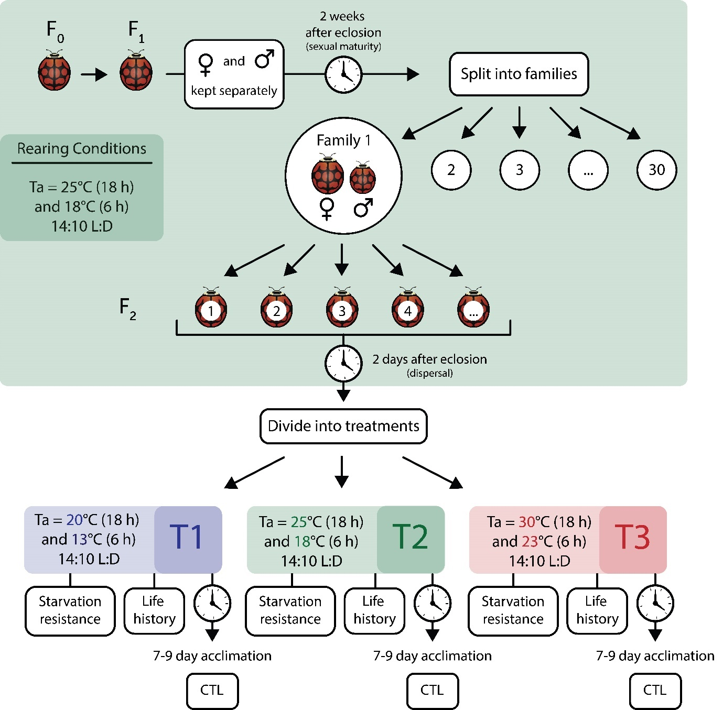

Figure S1. Study experimental design for rearing and determining physiological and life-history traits of the two beetle species. T1 to 3: treatments 1 to 3. CTL= Critical Thermal Limits. Ladybird illustration by Corneile Minnaar.

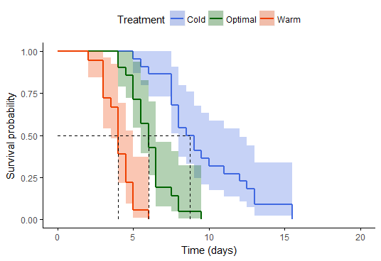
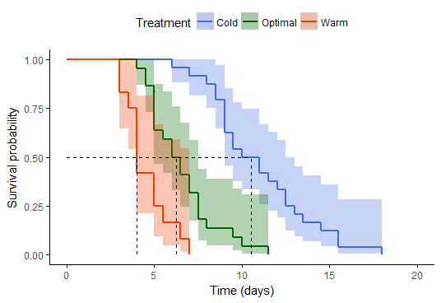
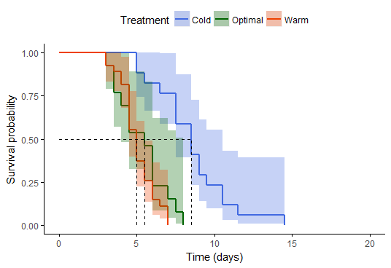
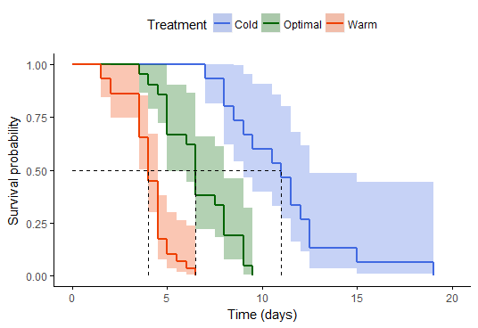
(a)
(b)

Figure S2. Kaplan-Meier survival curves used to plot starvation resistance data of Harmonia axyridis and Cheilomenes lunata for the cold (right - blue), medium (middle - green) and warm (left - orange) temperature treatments for beetles that had a) low mass loss (≤16.43%, the median mass loss percentage for all beetles in all treatments) and b) high mass loss (>16.43%) groups. Female data are shown on the left and males on the right. Dotted lines represent 50% survival probability per treatment and corresponding number of days. Species’ effects are not shown here but in Fig. 2 of main article.

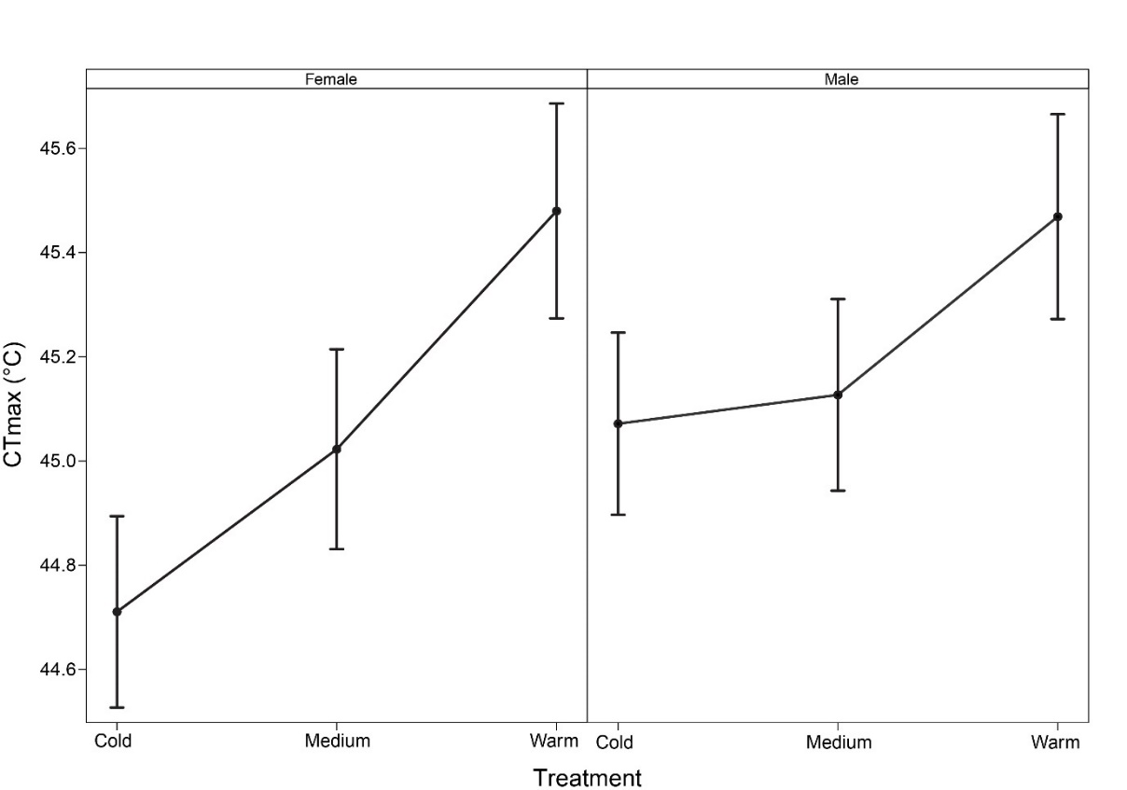

Figure S3. Critical thermal maximum (CT_{max}, °C) of male and female beetles of Harmonia axyridis and Cheilomenes lunata for each temperature treatment. Values are model parameter estimates.

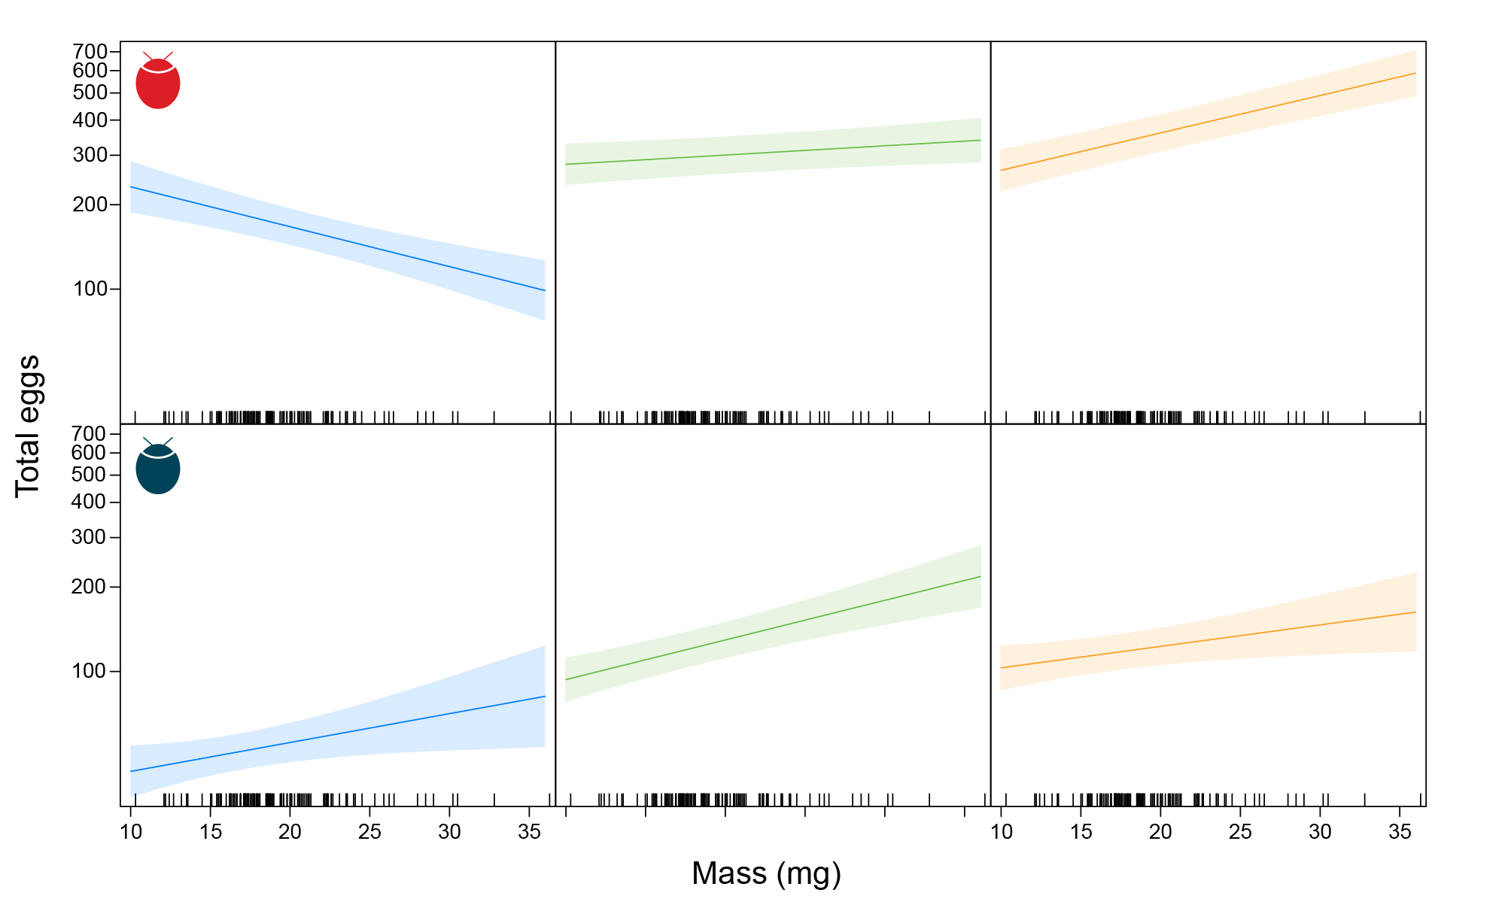
Figure S4. Total number of eggs laid by Harmonia axyridis (top row) and Cheilomenes lunata (bottom row) within the cold (left), medium (middle) and warm (right) treatments as a function of female body mass (mg). Values are model parameter estimates.
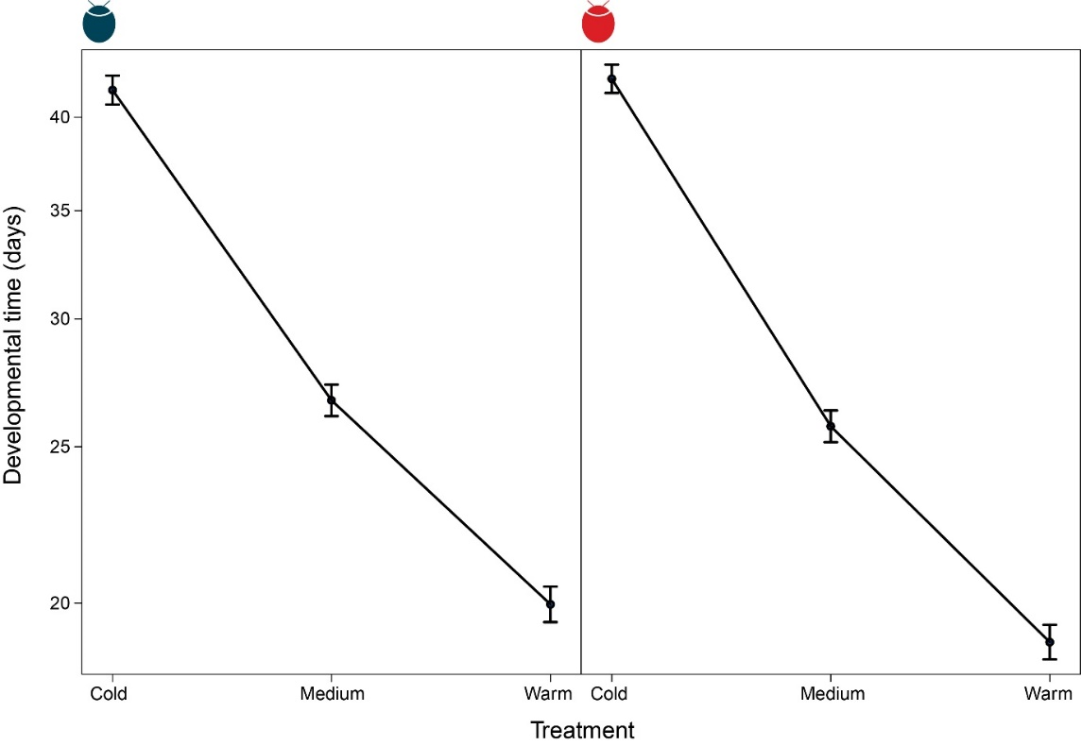
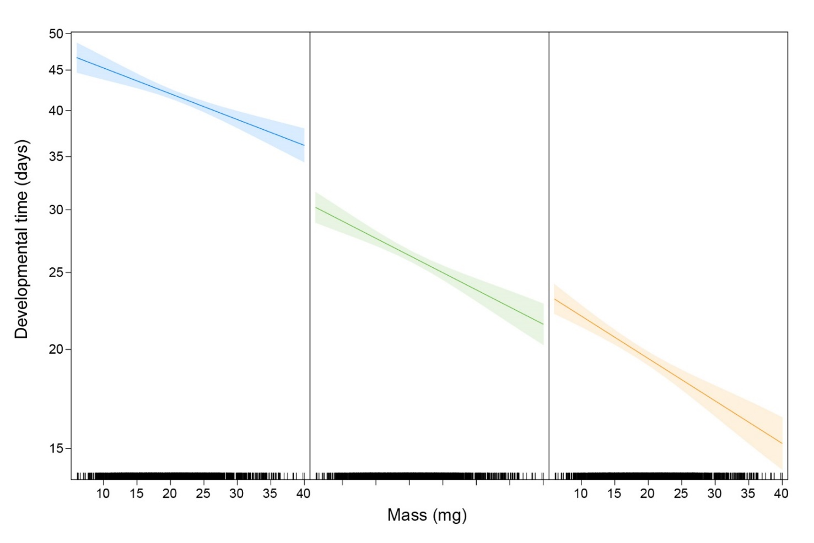
Figure S5. Developmental time (days) from egg to pupal emergence of Cheilomenes lunata (left) and Harmonia axyridis (right) in each temperature treatment. Values are model parameter estimates.

Figure S6. Developmental time (days) of Harmonia axyridis and Cheilomenes lunata beetles within the cold (left), medium (middle) and warm (right) treatments as a function of adult mass. Values are model parameter estimates.
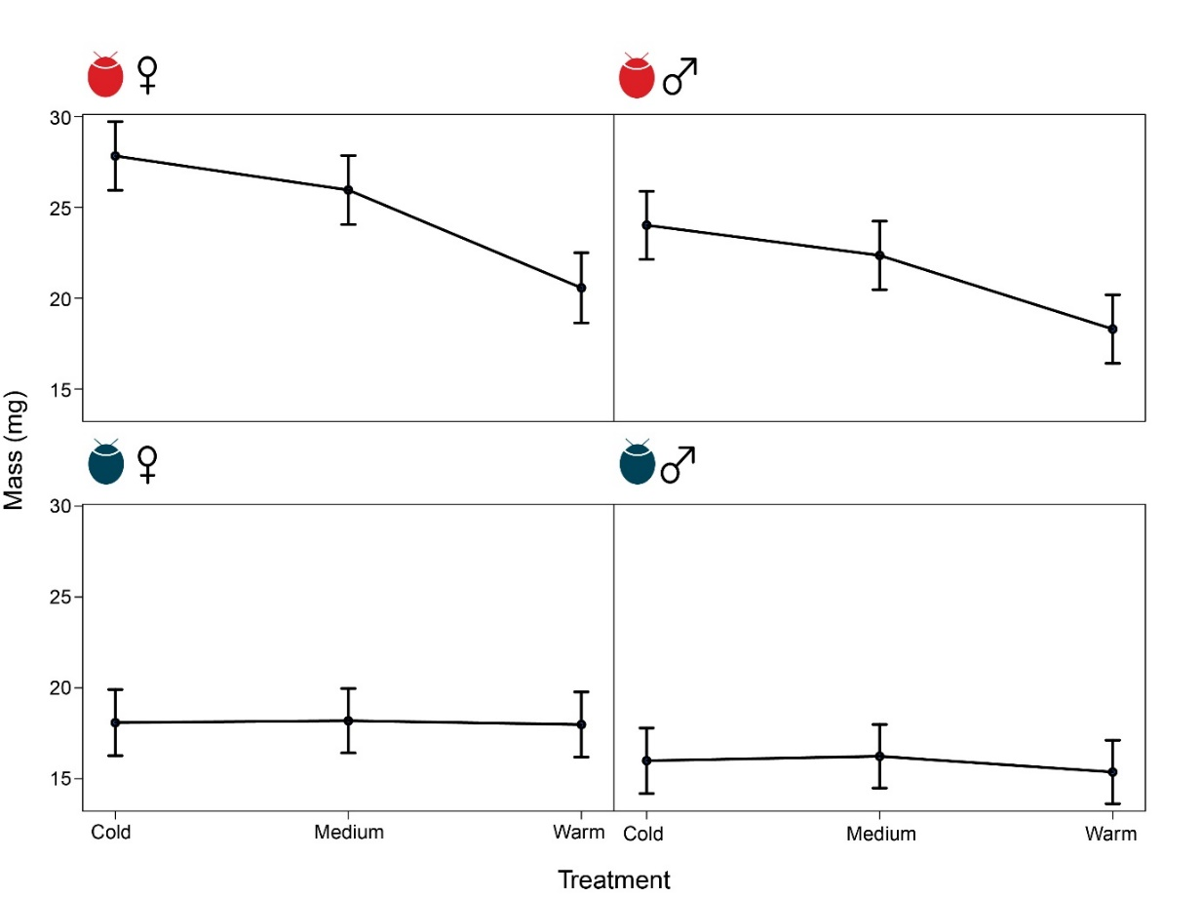
Figure S7. Adult (F3) mass (mg) of male and female Harmonia axyridis (top row) and Cheilomenes lunata (bottom row) within each temperature treatment. Values are model parameter estimates.

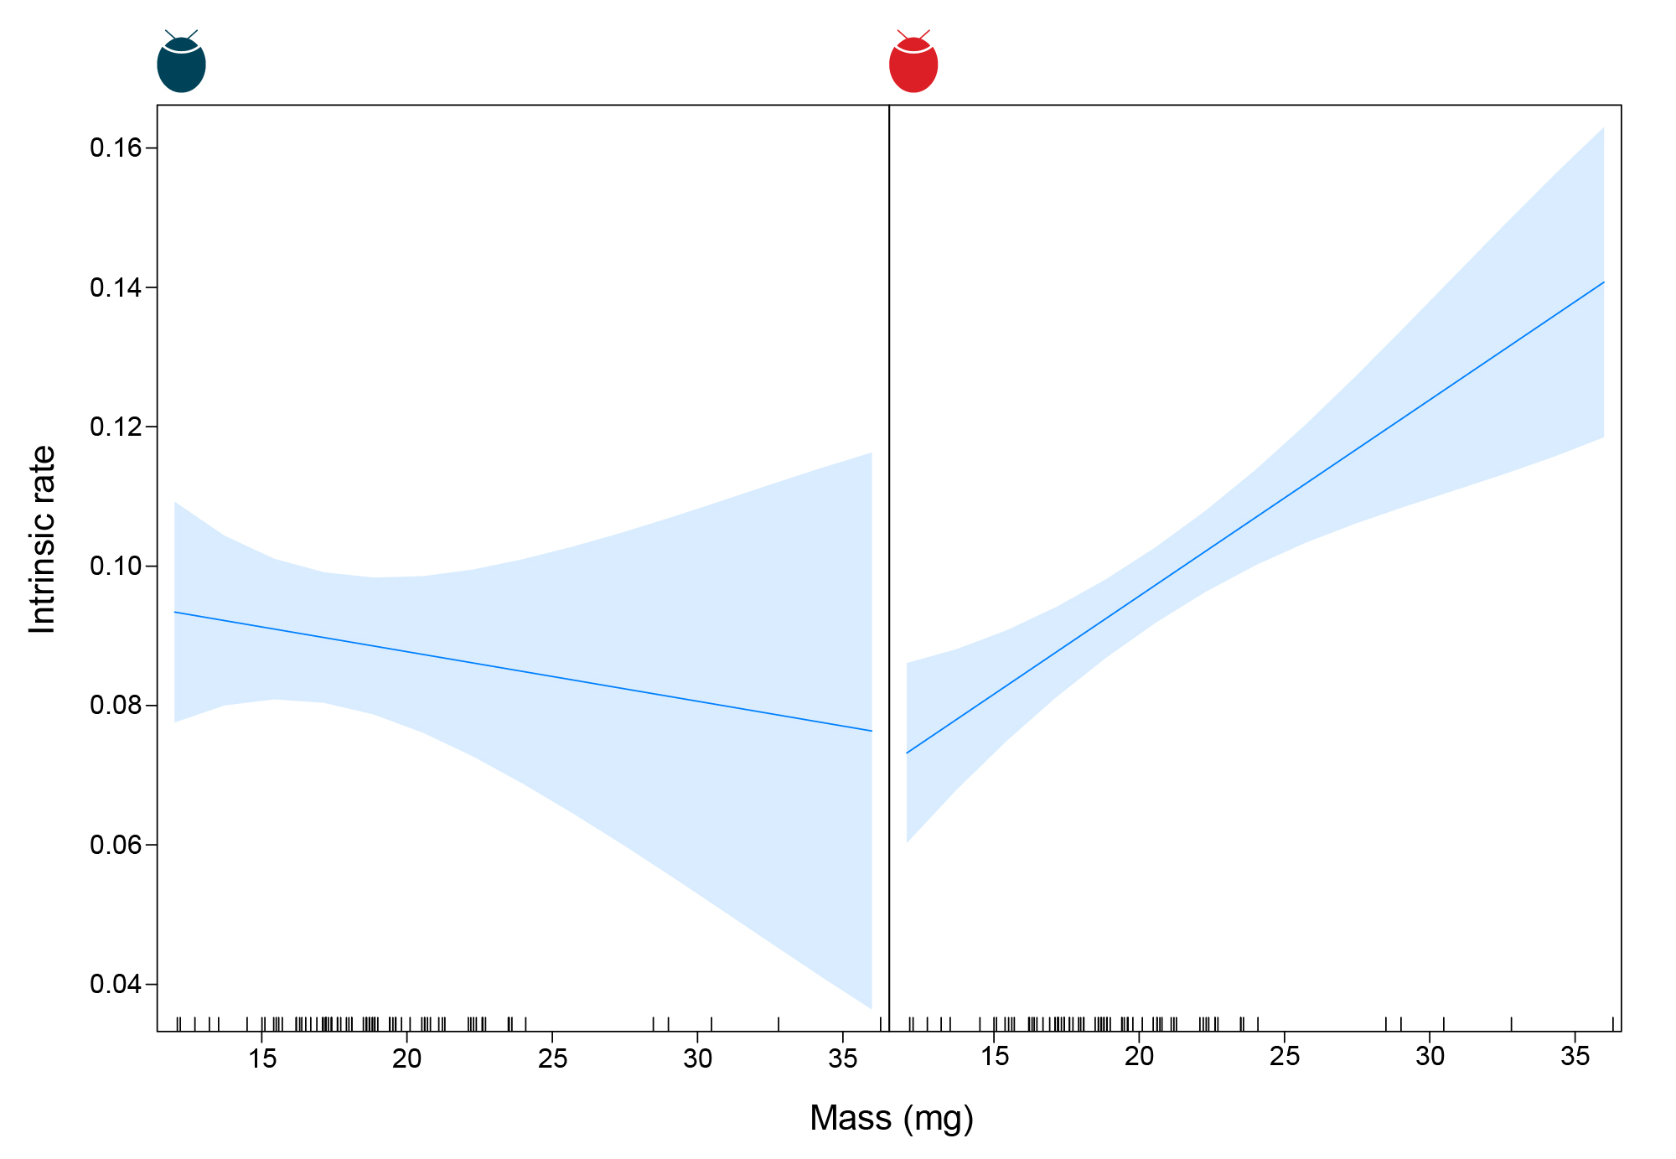
Figure S8. Intrinsic rate of increase of Cheilomenes lunata (left) and for Harmonia axyridis (right) as a function of female mass (mg). Values are model parameter estimates.

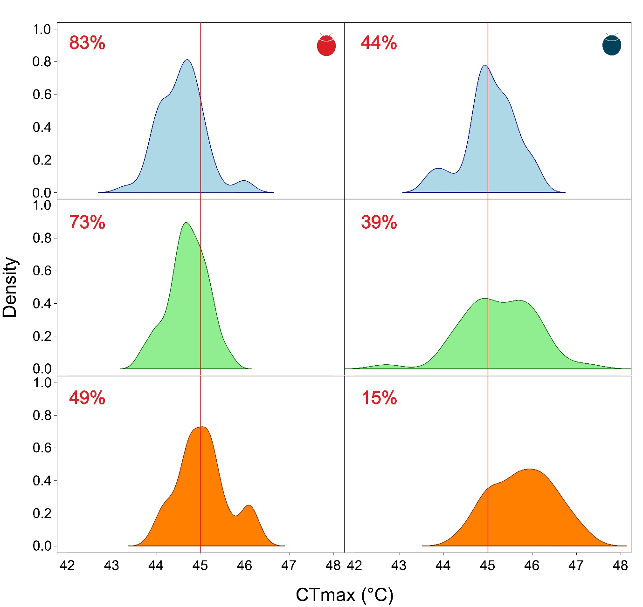
Figure S9 Density plots of measured critical thermal maximum (CT_{max}) data for Harmonia axyridis (left column) and Cheilomenes lunata (right column) in the cold (top row), medium (middle row) and warm (bottom row) treatments. The red line in each plot represents the heatwave event of 45°C experienced during simulations and the corresponding % mortality (individuals with CT_{max}<45°C) is shown in the upper left-hand corner. To estimate how many beetles survived the heatwave, CT_{max} was randomly sampled for each individual using the observed CT_{max} probability density distribution per temperature treatment for each species once established, and the number of individuals that had a CT_{max} >45°C was counted. The simulation ran for 1000 repeats for each species and each temperature scenario (all stages maintained at cold, medium or warm).

